The Paradox of Cultural Growth: Co-evolution of Cultural Genes, Innovation Networks, and Knowledge Traps in China
Mingxia He
Economics Department in Sichuan Since &Engineering University,
Zigong City, Sichuan Province China
E-mail: shinehe2012@gmail.com
Abstract
This paper revisits Joel Mokyr’s “Culture of Growth” hypothesis through the lens of regional science, revealing a “Cultural Paradox of Growth”: the same evolutionary mechanisms that foster a market for ideas can inadvertently lead to a “knowledge trap” of innovation stagnation. Utilizing a balanced panel of 285 Chinese cities from 2018 to 2020 and a unique “cultural gene” dataset derived from internet search behavior, we operationalize an H-B-F (Diversity–Bridging–Filtering) theoretical framework. Our spatial econometric analysis (SDM) and network simulations yield three paradoxes: (1) a Diversity Paradox, where cultural diversity facilitates innovation only up to an endogenous threshold, beyond which cognitive overload sets in;(2) a Spillover Paradox, identifying negative spatial spillovers where hyper-diverse hubs drain innovation resources from neighbors; and (3) an Evolution Paradox, showing how regional networks self-organize into high-filtering clusters, locking cities into suboptimal growth paths. These findings challenge the "more diversity is better" orthodoxy in economic geography and suggest that regional policy should pivot from agglomeration to network connectivity (Bridging) to escape the knowledge trap.
Keywords: Cultural Evolution; Innovation Networks; Knowledge Trap; Spatial Durbin Model; Regional Resilience; China

1. Introduction: The Three Paradoxes of Cultural Growth
The fundamental relationship between culture, knowledge creation, and sustained economic growth lies at the core of economic history and contemporary regional science. Joel Mokyr's influential "Culture of Growth" hypothesis posits that a specific set of cultural traits—namely, intellectual humility, tolerance for diverse ideas, and institutional incentives for sharing knowledge—were the essential ingredients that ignited the European Industrial Enlightenment, driving the self-sustaining engine of innovation. This perspective suggests that the willingness to create and participate in an open "market for ideas" is the ultimate determinant of a region's long-run prosperity. Following this logic, much of the contemporary economic geography literature has focused on agglomeration dynamics, emphasizing the role of urban density and cultural diversity in facilitating the critical interactions necessary for knowledge spillovers.
However, the empirical efficacy of diversity as a consistent engine of innovation is increasingly questioned. While high-diversity environments—the global hubs and metropolitan centers—unquestionably generate novelty, they simultaneously exhibit high rates of innovation stagnation, sometimes referred to as "knowledge traps," once the initial phase of rapid growth subsides. This emerging empirical reality presents a Cultural Paradox of Growth: the very evolutionary mechanisms and high-density environments designed to foster an open market for ideas can inadvertently lead to cognitive overload, resource drainage, and the rigid clustering of suboptimal innovation paths. Existing theoretical models, which tend to focus unidirectionally on maximizing diversity or minimizing transaction costs, struggle to explain this non-linear, self-limiting dynamic where cultural heterogeneity eventually ceases to be a net positive. The key missing piece in this debate is a granular framework that captures the process by which cultural inputs are transformed into productive knowledge outputs within regional networks, moving beyond simple input-output correlations.
To resolve this paradox, this paper introduces and operationalizes a Heterogeneity–Bridging–Filtering (H-B-F) theoretical framework. This framework argues that the relationship between cultural diversity (Heterogeneity) and innovation is entirely dependent on two mediating forces: Bridging and Filtering. Bridging refers to the connective capacity of a regional network, specifically the organizational, institutional, and relational mechanisms that translate latent cultural differences into productive, cross-disciplinary interactions. Filtering, conversely, represents the inertial forces—cultural homophily, administrative borders, institutional rigidity, and high cognitive distance—that inhibit the productive exchange of diverse ideas, leading to the rapid clustering of similar actors and the exclusion of novel, distant knowledge. Only when Bridging mechanisms are strong enough to overcome Filtering capacity can cultural heterogeneity realize its full innovative potential. The H-B-F model thus allows us to test the precise conditions under which diversity succeeds or fails, providing a necessary refinement to the prevailing "more diversity is better" orthodoxy in regional economic policy.
Utilizing the expansive and rapidly evolving urban landscape of China—a crucial laboratory for understanding state-guided knowledge evolution—we conduct a rigorous empirical analysis. Our data spans a balanced panel of 285 prefecture-level Chinese cities from 2018 to 2020. Critically, we introduce a unique, micro-level dataset derived from internet search behavior, allowing us to accurately proxy regional "cultural genes" and operationalize the crucial metrics of effective cultural diversity (ECD) and the H-B-F indicators. This empirical strategy is coupled with advanced spatial econometric and network simulation techniques. We employ a Spatial Durbin Model (SDM) to estimate the complex spatial interdependence and non-linearities, and we utilize the Exponential Random Graph Model (ERGM) to simulate the self-organizing evolutionary paths of inter-city innovation networks.
The central contributions of this paper rest on the empirical identification and structural explanation of three novel paradoxes challenging the conventional wisdom in regional science:
First, we operationalize Mokyr’s “Culture of Growth” hypothesis within a regional science framework. By developing a Diversity–Bridging–Filtering (H-B-F) theoretical model, we define a city’s cultural reproduction number ($R_{c}$). This formalizes how raw cultural heterogeneity (H) interacts with network connectivity (B) and institutional filtering (F) to determine whether a region enters a knowledge explosion or stagnation.
Second, we identify a “Diversity Paradox” and a “Spillover Paradox” at the city level using nonlinear spatial econometrics. Contrary to the linear "more is better" assumption in agglomeration economics, we provide robust evidence of a tipping point in cultural diversity (CCDI$≈0.45$). Furthermore, we reveal that while high-diversity hubs thrive, they often generate negative innovation spillovers to their neighbors, creating a "shadow of agglomeration" effect that demands spatial coordination.
Third, applying Exponential Random Graph Models (ERGM) to inter-city innovation networks, we uncover an “Evolution Paradox.” We find that while diversity drives individual city growth, the network self-organizes based on strong administrative and cultural homophily. This network structure, characterized by triadic closure and strong ties among similar actors, effectively locks regions into suboptimal evolutionary growth paths by minimizing exposure to radical, distant knowledge. We demonstrate that this structural characteristic is the mechanism by which regional systems become susceptible to the knowledge trap—not from a lack of potential diversity, but from a failure of the network to achieve sufficient Bridging.
In synthesizing these three paradoxes, this study offers a compelling theoretical pivot for regional policy. It argues that focusing solely on maximizing urban agglomeration and diversity is insufficient and potentially counterproductive. Instead, regional policy efforts should prioritize the construction of deliberate Bridging mechanisms—governance structures, institutional frameworks, and network platforms—that can proactively manage diversity, prevent information overload, and unlock the productive potential of heterogeneity. Escaping the knowledge trap requires a shift in focus from inputs (diversity) to processes (Bridging). The remainder of the paper are organized as follows: Section 2 introduces the H-B-F theoretical framework and formalizes the hypotheses; Section 3 details the data and variable construction; Section 4, presents and discusses the empirical results; Section5 concludes with policy implications and future research directions.
2. Theory and Model
2.1 Knowledge Creation: The Berliant–Fujita (BF) Micro-foundation
The Berliant–Fujita (BF) framework provides the micro-foundation for how interactions among heterogeneous agents generate new knowledge (Berliant & Fujita, 2008). Consider two agents i and j (e.g., firms, researchers, or cities) with knowledge sets Kᵢ and Kⱼ. Their knowledge stocks decompose into:
$$n_{ij}^{c}≡K_{i}∩K_{j}\text{(shared common knowledge)}$$
$$n_{ij}^{d}≡\frac{K_{i}}{K_{j}},n_{ji}^{d}≡\frac{K_{j}}{K_{i}\text{(differential knowledge components)}}$$
The collaborative idea-generation rate a₍ij₎ is:
$$\begin{matrix} & a_{ij}=β{\left(n_{ij}^{c}\right)}^{θ}{\left(n_{ij}^{d}n_{ji}^{d}\right)}^{\frac{1-θ}{2}},0<θ<1, β>0. & & \text{(1)}\end{matrix}$$
Common knowledge nᶜ facilitates communication (weighted by θ), while differential knowledge nᵈ supplies novelty (weighted by 1 – θ).The Cobb–Douglas form implies interior optimality: neither complete homogeneity (nᵈ → 0) nor total heterogeneity (nᶜ → 0) maximizes collaboration.
Aggregating across feasible pairs within region r, define a recombination efficiency:
$$\begin{matrix} & Φ_{r}≡\sum_{\left(i,j\right)∈r}{w_{ij}\left(B_{r}\right)} a_{ij},\frac{∂w_{ij}}{∂B_{r}}>0, & & \text{ (2)}\end{matrix}$$
where $w_{ij}\left(B_{r}\right)$ captures how bridging capital increases the likelihood that heterogeneous agents meet and successfully exchange ideas. Higher $B_{r}$improves match quality and quantity, raising productivity of the knowledge recombination engine.
2.2 Cultural Mechanisms: The Mokyr Network Structure
Mokyr’s (2016) cultural evolution theory explains how societies generate and select ideas through competition and selection among cultural variants. We adapt this to modern regional systems by embedding cultural bridging and filtering as institutional parameters regulating knowledge creation and adoption.
(1) Bridge capital and candidate ideas
Bridges connect distinct knowledge pools, increasing exposure to diverse cognitive inputs ($K_{d}$).In modern settings, they correspond to physical (transport) and virtual (digital) infrastructures, inter-city research collaboration, and shared scientific norms. Let Bₜ represent cultural bridge capital (trust, interoperability, communication codes).It scales the productivity of existing knowledge bases (Pₜ, Tₜ denoting propositional and technical knowledge stocks):
$$\begin{matrix} & {\dot{N}}_{t}=λ\left(B_{t}\right)P_{t}^{α}T_{t}^{β},λ^{'}\left(B_{t}\right)>0, α,β>0. & & \text{(3)}\end{matrix}$$
Thus, stronger bridging environments magnify idea generation and diversity activation.
(2) Filter stringency and adoption
Filters select, vet, and legitimize ideas through institutional mechanisms—peer review, patenting, venture screening, and ethical oversight.
Let Fₜ ∈ [0, 1] index filter stringency; adoption throughput S(Fₜ) satisfies S′(Fₜ) < 0.
The adopted innovation flow is:
$$\begin{matrix} & A_{t}=S\left(F_{t}\right) {\dot{N}}_{t}=S\left(F_{t}\right) λ\left(B_{t}\right)P_{t}^{α}T_{t}^{β}. & & \text{(4)}\end{matrix}$$
Moderate filtering improves average quality, while excessive filtering suppresses diversity and throughput.
(3) Effective Cultural Diversity（ECD）
We propose that innovation depends not on raw cultural diversity ($H_{t}$) perse, but on Effective Cultural Diversity ($ECD_{t}$). We define $ECD_{t}$as a function in which bridging capital ($B_{t}$) amplifies the productive potential of diversity, while filtering mechanisms ($F_{t}$) impose non-linear constraints that stabilize or dampen its effects:
$$ECD_{it}=α \left(H_{it}⋅B_{it}\right)-β \left(F_{it}^{2}\right)$$
Here, $α$captures the efficiency of access to diverse ideas and networks, whereas $β$represents the costs of cognitive processing or institutional rigidity that limit the realization of diversity’s benefits.
Further conceptualize raw cultural diversity $H_{t}$(e.g., measured by Shannon entropy) as being dynamically moderated by bridging and filtering processes. Specifically, bridges activate diversity’s communicative and integrative potential, while filters attenuate its effective range. This yields:
$$\begin{matrix} & Γ_{t}≡H_{t}\left(1+ω_{B}B_{t}\right)\left(1-ω_{F}F_{t}\right),ω_{B},ω_{F}>0. & & \text{(5)}\end{matrix}$$
Γₜ is the effective cultural diversity that enters both innovation technology and preferences, integrating heterogeneity, communicability, and selection, thus represents the effective cultural diversity that feeds into both the innovation production function and agents’ preference formation—integrating heterogeneity, communicability, and selective adaptation within a unified framework.
2.3 Endogenous Diversity Preference in Knowledge Production
We extend the BF–Mokyr mechanism into the Dixit–Stiglitz love-of-variety framework. Each city r hosts a continuum of differentiated varieties with upper-tier utility:
$$U_{r}=C_{A,r}^{1-μ}C_{M,r}^{μ},0<μ<1,$$
$$\begin{matrix} & C_{M,r}={\left(\int_{v∈Ω}{x_{r}{\left(v\right)}^{\frac{σ_{r}-1}{σ_{r}}} dv}\right)}^{\frac{σ_{r}}{σ_{r}-1}},σ_{r}>1. & & \text{(6)}\end{matrix}$$
Cultural endogeneity of preferences
Effective diversity${ Γ}_{r }$raises consumers’ love-of-variety by lowering substitution elasticity:
$$\begin{matrix} & σ_{r}=σ_{0}-ψΓ_{r},ψ>0, σ_{r}>1. & & \text{(7)}\end{matrix}$$
Hence, more “activated” heterogeneity (through high B and moderate F) intensifies demand for differentiated goods and ideas.
The manufacturing price index is:
$$\begin{matrix} & P_{r}={\left(\sum_{s}{n_{s}{\left(p_{s}τ_{sr}\right)}^{1-σ_{r}}}\right)}^{\frac{1}{1-σ_{r}}}, & & \text{(8)}\end{matrix}$$
where nₛ is the number of varieties from city s, pₛ its mill price, and${ τ}_{sr}$ ≥ 1 the iceberg trade cost.
2.4 Firms, Productivity, and Variety Entry
In each producing city s, a representative firm for variety v uses knowledge labor $L_{K,s}$.
Unit cost$cₛ ={{ w}_{\left(k,s\right)}}/{{ A}_{ₛ}},$ fixed cost f, and markup pricing yield:
$$\begin{matrix} & p_{s}=σ ˉ\frac{}{σ ˉ-1}c_{s},σ ˉ>1, & & \text{(9)}\end{matrix}$$
$$\begin{matrix} & R_{s}=σ ˉfw_{K,s}. & & \text{(10)}\end{matrix}$$
Aggregate demand across destinations implies revenue
$$R_{s}=p_{s}^{1-σ}\sum_{r}{E_{r}τ_{S^{τ}}^{1-σ_{r}}}{P_{τ}^{σ_{r}}}^{-1}$$
Total factor productivity links knowledge and effective diversity:
$$\begin{matrix} & A_{s}=A_{0}K_{s}^{α}Γ_{s}^{η},α,η>0. & & \text{(11)}\end{matrix}$$

Effective diversity thus raises productivity through both supply (knowledge efficiency) and demand (variety valuation) channels.
2.5 Knowledge Dynamics, Spatial Spillovers, and Adoption
City r’s knowledge stock evolves as:
$$\begin{matrix} & {\dot{K}}_{r}=λΦ_{r}Γ_{r}^{η}+δ\sum_{s}{ω_{rs}}K_{s}-δ_{K}K_{r},δ,δ_{K}>0. & & \text{(12)}\end{matrix}$$
Adopted innovations (e.g., patents) are:
$$\begin{matrix} & I_{r}=S\left(F_{r}\right){\dot{K}}_{r}. & & \text{(13)}\end{matrix}$$
Spatial and relational weights follow an endogenous innovation-network kernel:
$$\begin{matrix} & W_{rs}≡ξ{\left(n_{r}n_{s}\right)}^{ζ}{\left(τ_{rs}\right)}^{1-σ ˉ }{\left(Γ_{r}Γ_{s}\right)}^{χ},ω_{rs}=\frac{W_{rs}}{\sum_{j}{W_{rj}}}, ζ,χ>0. & & \text{(14)}\end{matrix}$$
Bridging capital boosts$Φ_{r}$and$W_{rs}$ (by facilitating collaboration and diffusion), while filtering reduces $S\left(F_{r}\right)$.
Equation (12)— (14) jointly capture spatial knowledge spillovers and the cultural reproduction feedback:
$H_{t+1}=φH_{t}+η_{net}+μ_{inst},φ∈\left(0,1\right),$ （15）
embedding cultural inertia φ and institutional interventions $μ_{inst}$.

2.6 Propositions and Comparative Statics
A spatial general equilibrium consists of $\left(P_{s},n_{s},P_{r},σ_{r,}K_{r},A_{s},I_{r}\right)$satisfying equations (6)–(14) under goods and factor-market clearing. Knowledge labor mobility can be added via:
$${\dot{L}}_{K,r}=ν\left(\ln{U_{r}}-\ln{\overline{U}}\right),$$
where $U_{r}={w_{K,r}}/{P_{r}}$× amenities
Proposition 1 (Effective Diversity and Innovation). If $\frac{∂σ_{r}}{∂Γ_{r}}=-ψ<0$and $\frac{∂A_{r}}{∂Γ_{r}}>0$, then under free entry:
$$\frac{∂n_{r}}{∂Γ_{r}}>0,\frac{∂I_{r}}{∂Γ_{r}}>0.$$
Activated heterogeneity ($Γ↑$) increases both the number of varieties and the innovation output.
Proposition 2 (Bridging–Filtering Trade-off).
$$\frac{∂n_{r}}{∂B_{r}}>0,\frac{∂I_{r}}{∂B_{r}}>0;\frac{∂n_{r}}{∂F_{r}}<0,\frac{∂I_{r}}{∂F_{r}}<0.$$
Moderate filtering enhances innovation by balancing quality and throughput; excessive filtering leads to stagnation.
Proposition 3 (Interior Optimum of Heterogeneity).From equations (1)–(2), innovation is maximized when cultural proximity allows comprehension ($n^{c}>0$) while cognitive distance ($n^{d}>0$) ensures novelty. Both uniformity and fragmentation yield suboptimal recombination efficiency.
Proposition 4 (Spatial Thresholds and Polycentricity). Given the spatial kernel (14), inter-city coupling strengthens when communication frictions $τ_{rs}$fall below a threshold $τ^{*}$or when $Γ_{r}$rises. Regions with high $Γ_{r}$and low $τ_{rs}$form multiple innovation hubs; excessive isolation or over-filtering collapses this structure into a monocentric, low-innovation equilibrium.
2.7 Integrating Cultural Evolution: The Cultural Reproduction Index ($R_{c}$)
Following epidemic diffusion models, we define the condition for a take-off in the market for ideas through the basic reproduction number of knowledge ($R_{c}$). In this framework:
$R_{c}=\frac{\text{Transmission Rate}×\text{Susceptible Ideas}}{\text{Decay Rate}}≈\frac{B\left(H\right)}{F}$ （16）
Here, $B\left(H\right)$represents the effective transmission or diffusion potential of ideas as enhanced by bridging networks and cultural diversity, while $F$captures decay forces such as institutional inertia, cognitive saturation, or social filtering.
When $R_{c}>1$, idea transmission becomes self-sustaining, leading to a cumulative and accelerating expansion of knowledge—analogous to Mokyr’s notion of a “Culture of Growth.” Conversely, when $R_{c}<1$, idea diffusion fails to reach critical mass, and the system remains trapped in stagnation.
This formulation thus provides a micro-foundation for the threshold dynamics empirically examined in Section 4, linking cultural structure and institutional frictions to the non-linear propagation of innovation. Bridging (B ↑) and adaptive filtering (F moderate) push$R_{c}$above unity, while over-stringent filtering or cultural inertia (φ → 1) push${ R}_{c}$below 1.
This formulation unites the mechanisms of diversity, spillover, and evolution into a single dynamic equilibrium condition:
$$\frac{dB}{dt}+\frac{df}{dt}≥\frac{dH}{dt}.$$
When this balance holds, the cultural reproduction number remains above unity, ensuring that diversity continuously regenerates creativity rather than fragmenting it.
The notation and definitions are list as Table 1.
Table 1. Notation and Definitions
Symbol | Concept | Proxy / Measurement | Role in H-B-F Framework
H | Raw Cultural Heterogeneity | CCDI (Composite Cultural Diversity Index) | The pool of potential ideas (Mutations).
B | Bridging Capital | Bridge Index (Infrastructure + Market) | The velocity of idea transmission.
F | Filtering Capacity | Filter Index (Institutions + Human Capital) | The selection pressure on ideas.
ECD | Effective Cultural Diversity | ECD = f(H, B, F) | The net diversity actually available for recombination.
Rc | Cultural Reproduction Number | Derived Function (see Eq. 3) | Threshold parameter: Growth if Rc > 1.

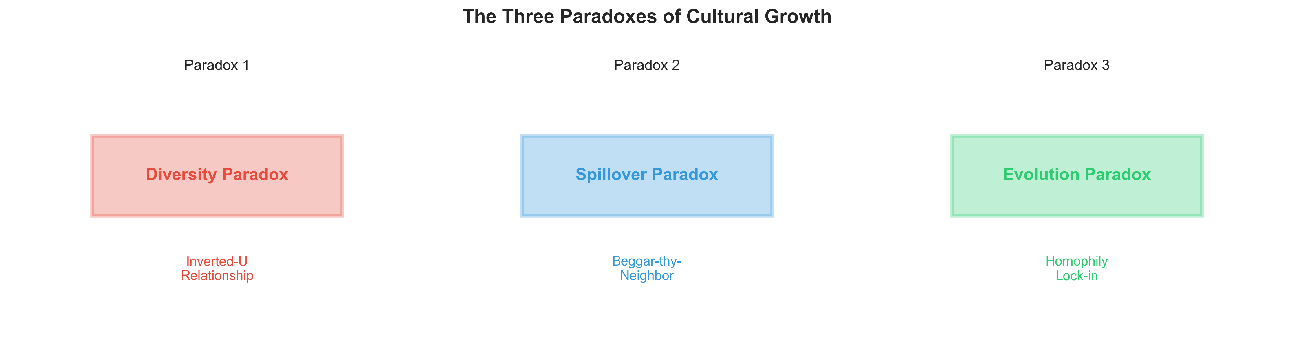
Figure 1: The Three Paradoxes of Cultural Growth - Conceptual Framework

3. Variables and Measurement
To operationalize the H–B–F (Heterogeneity–Bridging–Filtering) theoretical framework, we constructed a comprehensive indicator system using a balanced panel of 285 Chinese cities from 2018 to 2020. The construction and processing of core variables are detailed below.
3.1 Core Explanatory Variables: The H–B–F Indices
3.1.1 Raw Cultural Heterogeneity (H): The CCDI
We measure the potential "gene pool" for recombinant innovation using the Composite Cultural Diversity Index (CCDI). Unlike previous studies that rely on single proxies, our CCDI (Version 4) integrates three dimensions of diversity—historical, demographic, and attitudinal—to capture the full spectrum of cognitive heterogeneity.
The CCDI is a weighted composite constructed via Principal Component Analysis (PCA) of the following sub-indicators:
Historical Heterogeneity: Measured by the Dialect Diversity Index (DDI), which reflects the fragmentation of local linguistic lineages, and the Religious Cultural Diversity Index (RCDI), calculated based on the spatial entropy of Buddhist, Taoist, Islamic, and Christian institutions.
Demographic Heterogeneity: Measured by Migration Cultural Entropy (MCE). We trace the origin provinces of the floating population in each city and calculate the Shannon entropy of their geographic sources, capturing the diversity of incoming skills and habits.
Modernity Heterogeneity: Measured by the newly constructed Modernity Index. Derived from the World Values Survey (WVS), this index aggregates city-level scores on "Traditional vs. Secular-Rational" and "Survival vs. Self-Expression" values. It proxies the cognitive friction and diversity generated by the collision between traditional norms and modern industrial values.
All sub-indicators are standardized using min–max normalization before aggregation. The first principal component extracted via PCA defines the final CCDI. Higher ${”CCDI” }_{it}$values denote more heterogeneous cultural environments and serve as the theoretical proxy for $H_{it}$.
To capture potential non-linear effects, both ${”CCDI” }_{it}$and its squared term ${”CCDI” }_{it}^{2}$are included in the regression models to test for the hypothesized diversity threshold effect.
$$H_{it}={\text{CCDI}}_{it}, H_{it}^{2}={\left({\text{CCDI}}_{it}\right)}^{2}$$
3.1.2 Bridging Capital (B): The Bridge Index
Bridging Capital represents the velocity and breadth of idea transmission. We construct the Bridge Index to capture both physical connectivity and market integration:
Physical Connectivity: Includes the density of high-speed rail (HSR) networks, airport connectivity, and Broadband Penetration (internet access users), which facilitate the physical and digital movement of innovators.
Market & Information Connectivity: We introduce the Market Mechanism Bridge Index, which measures the reduction in inter-regional trade barriers and factor mobility costs. Additionally, total Telecom Business Volume is included to proxy the frequency of information exchange.
Each sub-indicator is normalized and aggregated using PCA to form the composite Bridge Index ($B_{it}$). Higher $B$values indicate structurally open and well-connected cities capable of spanning “structural holes,” thereby enhancing the productive contribution of cultural heterogeneity ($H$).
$$B_{it}=f\left({\text{Connectivity}}_{it},{\text{Mobility}}_{it},{\text{Linkages}}_{it}\right)$$
3.1.3 Filtering Capacity (F): The Filter Index
Filtering Capacity represents the selection pressure that screens out inferior ideas and converts diversity into economic output. The Filter Index is composed of institutional and factor-based selection mechanisms，Institutional Selection:
Fair Competition Review Score: A novel indicator measuring the intensity of local government efforts to abolish regulations that impede a unified market. A higher score indicates a more transparent, rule-based environment that selects firms based on merit rather than rent-seeking.
IP Protection Strength: Measured by patent enforcement rates and judicial efficiency in IP cases.
Factor Selection: Includes Human Capital Agglomeration (number of "Double First-Class" universities and R&D density) and the Marketization Index (focusing on the development of non-state sectors), which ensure that resources flow to the most productive innovations.
The normalized indicators are aggregated using PCA to construct the composite Filter Index ($F_{it}$). The theoretical model predicts a non-linear stabilizing cost associated with excessive filtering. Therefore, the empirical specification includes both $F_{it}$and $F_{it}^{2}$to capture diminishing or adverse effects at very high filtering levels, where institutional rigidity may inhibit creative experimentation.
$$F_{it}=f\left({\text{InstitutionalQuality}}_{it},{\text{HumanCapital}}_{it},{\text{Finance}}_{it},{\text{Openness}}_{it}\right)$$
$$F_{it}^{2}={\left(F_{it}\right)}^{2}$$
3.1.4 Effective Cultural Diversity (ECD)
The core hypothesis of this paper is that "raw" diversity implies potential, while "effective" diversity drives growth. We define Effective Cultural Diversity (ECD) as the net diversity available for recombination after being modulated by bridging and filtering forces.
In our empirical model, ECD is operationalized through interaction terms and a derived index:
ECDᵢₜ = Hᵢₜ × Bᵢₜᵅ × Fᵢₜᵝ
Specifically, we test the interactions H × B (to verify if bridging alleviates cognitive congestion) and H × F (to verify if filtering enhances conversion efficiency).
3.2 Dependent Variable: Innovation Network Position (Y)
The dependent variable is the Innovation Network Position, measuring a city's influence and prominence within the co-application patent network. We construct this network annually based on the co-inventorship between firms/institutions located in different cities. A directed link (i → j) exists if City i and City j collaborate on a patent.
We use Weighted In-Degree Centrality to capture a city's network position, as it represents the extent to which a city is sought out by other cities for knowledge collaboration. This reflects the city's ability to attract external knowledge flows, which is a direct measure of its innovation appeal and central influence. The formula for calculating a city's innovation attractiveness and core position within the network is as follows:
$$Y_{it}=\sum_{j≠i}^{N}{w_{ji,t}}$$
Where:
$Y_{it}$: Represents the Innovation Network Position of city $i$in year $t$, measured by Weighted In-Degree Centrality. This indicator reflects the city's ability to attract external knowledge flows and its central influence within the knowledge network.
$N$: Denotes the total number of cities in the network.
$w_{ji,t}$: Represents the connection weight from city $j$to city $i$. In the patent collaboration network, this specifically refers to the number of patents co-applied by city $j$and city $i$in year $t$. A higher weight indicates stronger knowledge collaboration between city $j$and city $i$in year $t$.

3.3 Data Processing and Index Construction
To ensure comparability and address multicollinearity, we applied the following data processing protocol:
Missing Value Imputation: Linear interpolation was used for minor gaps in time-series data, while cross-sectional mean replacement (within the same province) was applied for missing static data.
Dimensionless Processing: All raw indicators were normalized using the Min-Max method to map values to the [0, 1] interval:
$$Z_{ijt}=\frac{X_{ijt}-\min\left(X_{j}\right)}{\max\left(X_{j}\right)-\min\left(X_{j}\right)}$$
For cost-type indicators (e.g., market barriers), we used the inverse normalization.
PCA Weighting: The weights for the sub-indicators within the CCDI, Bridge, and Filter indices were determined dynamically using the loadings from the first principal component (PC1) to objectively reflect their contribution to the latent variable.
3.4 Control Variables and Description
To isolate the cultural and network effects, a comprehensive set of time-varying control variables is incorporated. These controls address potential confounding influences stemming from a city's economic scale, industrial structure, human capital, and technological input.
Table 3: Control Variables and Description
Variable | Description | Transformation
ln(GDP/Capita) | Economic development | Natural log
ln(Population, Density) | Urban scale and density | Natural log
IndUp, Tertiary | Industrial upgrading, tertiary share | Percentage
CollegeShare | Higher education attainment | Standardized share
ln(R&D, S&TPersonnel) | R&D investment and S&T personnel | Natural log
Digital Economy Index | Digitalization level | PCA-based index
ln(ListedFirms, HiTech) | Market activity and industrial clustering | Natural log
All monetary and count variables are transformed using the natural logarithm to reduce skewness and linearize relationships. Categorical indices such as Industrial Upgrading and Digital Economy Development are standardized to the [0,1] interval to ensure comparability.
The panel data structure further incorporates:
City Fixed Effects (μᵢ), controlling for time-invariant unobserved heterogeneity (e.g., geography, historical legacies, or deep-rooted cultural traits not captured by CCDI); and
Year Fixed Effects (λₜ), accounting for nationwide policy changes or macroeconomic shocks common to all cities.
Together, these specifications provide a robust empirical foundation for testing the spatial dynamics of innovation and ERGM under the H–B–F framework, enabling the decomposition of innovation outcomes into cultural activation and institutional attenuation effects.

Proxy / Index | Measurement Dimensions | Specific Indicators / Variables
CCDI (Composite Cultural Diversity Index) | Historical & institutional heterogeneity | • Traditional academies (Shuyuan) count
 |  | • Religious institution distribution (Buddhist, Taoist, Islamic, Catholic, Protestant/Christian)
 |  | • Dialect Diversity Index (DDI; in CSV)
 | Attitudinal & modernity heterogeneity | • WVS value dispersion (Traditional vs. Secular-Rational; Survival vs. Self-Expression)
 |  | • Generalized trust index; autonomy indicator
 | Demographic heterogeneity | • Migrant origin-province heterogeneity (Migration Cultural Entropy, MCE; in CSV)
 |  | • Religious–ethnic diversity index (RCDI; in CSV)
Bridge Index (Infrastructure + Market) | Physical connectivity | • High-speed rail (HSR) accessibility
 |  | • Airport network density
 |  | • Broadband penetration (broadband users; in CSV)
 | Human & market mobility | • Migration intensity; commuting patterns
 |  | • Academic/professional exchange programs
 |  | • Market Mechanism Bridge Index (Market_Bridge; in CSV)
 |  | • Regional openness (FDI and trade)
 | Institutional linkage & collaboration | • Inter-city R&D collaboration counts
 |  | • Co-patenting partnerships
 |  | • Participation in national innovation programs
Filter Index (Institutions& Human Capital) | Institutional & market quality | • Local governance efficiency
 |  | • IP protection strength (IP_Protection; in CSV)
 |  | • Rule of law index
 | Human capital selectivity | • Number of top universities
 |  | • Number of national key laboratories
 |  | • Number of major tech firms / incubators
 | Financial selectivity | • Venture capital intensity
 |  | • Density of professional investors
 |  | • Access to innovation financing channels
 | Openness & competition intensity | • China marketization index (Market_Index_Lerner; in CSV)
 |  | • Fair Competition Review score (regulatory barriers / transparency)
Derived function: ECD = H × B^α × F^β | Composite outcome | Effective cultural diversity index (ECD_v3; in CSV), computed from interactions among H, B, and F.
Derived function (see theoretical model Eq. 3) | Threshold indicator | Computed value indicating whether the cultural system expands or contracts.


Figure 1: The Three Paradoxes of Cultural Growth - Conceptual Framework

Table 4: Summary Statistics of Key Variables (N = 859)
Variable Name | Mean | Std. Dev. | Min | Max
CCDI_v4 | 0.3024 | 0.0771 | 0.0981 | 0.7675
Bridge_new (Bridging Index) | 0.4496 | 0.1121 | 0.1436 | 0.8071
Filter_new (Filtering Index) | 0.1809 | 0.0815 | 0.0307 | 0.5748
ECD (Effective Cultural Diversity) | 0.0862 | 0.0721 | 0.0097 | 0.6733
CCDI_v4_dm_sq (Squared Cultural Distance) | 0.0059 | 0.0174 | ~0 | 0.2163
GDP (billion RMB) | 326.64 | 463.65 | 20.44 | 3896.33
Industrial Upgrading Index | 1.3738 | 0.6754 | 0.3641 | 5.244
Digital Innovation Index | 74.31 | 16.74 | 27.06 | 99.92
Listed Firms Count | 16.65 | 47.52 | 0 | 436
Weighted Degree Centrality | 1362.05 | 3110.83 | 0 | 31960
Weighted In-Degree | 681.35 | 1500.99 | 0 | 13908
Degree Centrality | 0.2536 | 0.1978 | 0 | 0.8838
PageRank Centrality | 0.0035 | 0.0051 | 0.0005 | 0.0492
Network Density | 0.1698 | 0.0257 | 0.1384 | 0.2013

4. Empirical Design: Testing the Cultural Paradox of Growth
This section presents the empirical strategy used to identify and test the three paradoxes derived from the theoretical framework: (1) the Diversity Paradox, which posits an inverted-U relationship between cultural heterogeneity and innovation; (2) the Spillover Paradox, which arises when knowledge diffusion produces spatial inequality; and (3) the Evolution Paradox, which reflects how network structures and institutional rigidity transform creativity into lock-in. Each model targets one dimension of this Cultural Paradox of Growth, progressively linking micro-level collaboration, meso-level network dynamics, and macro-level regional interdependence.
4.1 Preliminary Test: Evidence for Diversity Nonlinearity
We begin with a two-way fixed-effects panel regression to test the core hypothesis that innovation increases with cultural diversity up to an endogenous optimum—the essence of the Diversity Paradox. The key terms of the specification are:
$$\ln{Y_{it}}=α_{i}+λ_{t}+β_{1}\ln\left(CCDI_{it}\right)+β_{2}{\left[\ln\left(CCDI_{it}\right)\right]}^{2}+β_{3}B_{it}+β_{4}F_{it}+β_{5}F_{it}^{2}+β_{6}\left(\ln\left(CCDI_{it}\right)×B_{it}\right)+β_{7}\left(\ln\left(CCDI_{it}\right)×F_{it}\right)+β_{8}\left(B_{it}×F_{it}\right)+γ^{'}X_{it}+ε_{it}.$$
Here, $Y_{it}$denotes innovation output (log of weighted degree centrality), $X_{it}$includes control variables, $α_{i}$and $λ_{t}$are city and year fixed effects, and $ε_{it}$is the idiosyncratic error term.The parameters $β_{1}>0$and $β_{2}<0$would confirm the inverted-U effect of diversity — the essence of the Diversity Paradox. Interaction terms evaluate moderation effects: $β_{6}>0$indicates that bridging amplifies the gains from diversity, while $β_{7}<0$implies that excessive filtering dampens them. The quadratic term $F_{it}^{2}$captures the nonlinearity of institutional selectivity (expected $β_{4}<0,β_{5}>0$), consistent with the theoretical notion that both weak and over-stringent filters reduce innovation. To verify robustness, we also estimate an alternative specification using effective cultural diversity (ECD) — a composite indicator of “activated heterogeneity”:
$$\ln{Y_{it}}=α_{i}+λ_{t}+θ_{1}ECD_{it}+θ_{2}ECD_{it}^{2}+θ_{3}^{'}X_{it}+ε_{it}.$$
These regressions provide the first empirical test of whether regions can maintain innovative vitality only when bridging and filtering evolve fast enough to match rising heterogeneity. The estimated turning point of the diversity curve thus corresponds to the boundary between creative integration and fragmentation — the operational measure of the Cultural Paradox of Growth.
4.2 Core Identification: Threshold Analysis of Adaptive Diversity Shifts
To assess whether the diversity–innovation relationship exhibits distinct regimes, we apply Hansen’s (1999) panel threshold model. The specification allows for an endogenous break at a threshold level $τ$:
$$\ln{Y_{it}}=α_{i}+λ_{t}+β_{L}CCDI_{it}⋅I\left(CCDI_{it}≤τ\right)+β_{H}CCDI_{it}⋅I\left(CCDI_{it}>τ\right)+δ^{'}X_{it}+ε_{it}.$$
The optimal threshold $τ$is identified via grid search minimizing the residual sum of squares, and its statistical significance is tested through bootstrap confidence intervals.
A pattern of $β_{L}>0$and $β_{H}<β_{L}$indicates that innovation rises with diversity up to a critical level and declines thereafter — confirming the Diversity Paradox.
To explore adaptive dynamics, we allow the threshold to vary with bridging and filtering:
$$τ_{i}=τ_{0}+τ_{B}B_{i}+τ_{F}F_{i}.$$
Theory predicts that stronger bridging shifts the optimum rightward ($τ_{B}>0$) by enabling the system to absorb greater heterogeneity, whereas stricter filtering shifts it leftward ($τ_{F}<0$) by narrowing tolerance for diversity. We visualize this “drifting threshold” as a surface $H^{*}\left(B,F\right)$, where higher $B$and moderate $F$jointly elevate the productive potential of diversity. This empirical exercise operationalizes the system condition $\frac{dB}{dt}+\frac{dF}{dt}≥\frac{dH}{dt}$: innovation remains self-sustaining ($R_{c}>1$) when social and institutional adaptation keeps pace with diversification.
4.3 Spatial Spillover Models: The Spillover Paradox
While the previous models focus on intra-regional mechanisms, innovation processes are inherently spatial. Knowledge diffuses across cities through both market and network channels, but these spillovers can generate asymmetric effects. To capture this tension, we estimate Spatial Lag of X (SLX) and Spatial Durbin Models (SDM).
(a) SLX Model
$$\ln{Y_{it}}=β_{0}+β^{'}X_{it}+θ^{'}{\left(WX\right)}_{it}+α_{i}+λ_{t}+u_{it},$$
where $W$is a spatial weight matrix, and ${\left(WX\right)}_{it}$represents spatially lagged covariates such as $\operatorname{Wln}{CCDI_{it}}$or $WECD_{it}$.
A negative $θ$on the spatial lag of diversity under a geographic matrix implies that neighboring diversity exerts competitive pressure—an empirical signature of the Spillover Paradox, where innovative hubs siphon resources from surrounding areas.
(b) SDM Model
To distinguish endogenous from exogenous interdependence, we extend the analysis to the Spatial Durbin Model:
$$\ln{Y_{it}}=ρ{\left(\operatorname{Wln}{Y}\right)}_{it}+β^{'}X_{it}+θ^{'}{\left(WX\right)}_{it}+α_{i}+λ_{t}+u_{it}.$$
Here, $ρ$captures direct dependence among innovation outputs, while $θ$traces spillovers in cultural and institutional characteristics.
We employ three types of spatial weight matrices to identify distinct channels of diffusion:
$W^{\left(geo\right)}$: inverse-distance geographic neighbors;
$W^{\left(cul\right)}$: cultural proximity based on dialect and migration similarity;
$W^{\left(net\right)}$: innovation-network adjacency derived from the previous year’s collaboration links.
Comparing across these matrices allows us to disentangle competitive geographic spillovers from cooperative cultural or relational ones.
Impact decomposition (LeSage and Pace, 2009) yields total, direct, and indirect effects. A negative indirect effect under $W^{\left(geo\right)}$indicates spatial polarization (competition), while a positive one under $W^{\left(cul\right)}$signals beneficial knowledge diffusion among culturally proximate regions. These results empirically verify the Spillover Paradox — that the same bridging forces which enhance local innovation may simultaneously deepen inter-regional inequality when bridging capacity and absorptive potential are unevenly distributed.
4.4 Network Formation and the Evolution Paradox
To uncover the micro-foundations of structural change and potential lock-in, we model the formation of inter-city innovation ties using an Exponential Random Graph Model (ERGM).This approach directly addresses the Evolution Paradox — how adaptive mechanisms that once foster diversity can evolve into rigid, self-reinforcing structures.
Let $Y_{t}$be the adjacency matrix of the innovation network at time t; the ERGM is specified as:
$$\operatorname{Pr}\left(Y_{t}=y\right)=\frac{\exp\left[θ^{'}g\left(y\right)\right]}{κ\left(θ\right)},$$
where $g\left(y\right)$is a vector of network statistics and covariate-based terms, $θ$the associated parameter vector, and $κ\left(θ\right)$the normalizing constant.
The included terms are: Edges (baseline network density),GWESP (geometrically weighted edgewise shared partners, capturing triadic closure),Degree-related terms (alternating k-stars, representing preferential attachment), and Attribute-based mixing terms, including ProvMatch (same-province indicator) and Cultural Distance $∣ΔECD_{ij,t}∣$.Node-level attributes, such as $CCDI_{i}+CCDI_{j}$and $∣CCDI_{i}-CCDI_{j}∣$, assess whether culturally rich cities attract more collaborations and whether dissimilarity impedes connection.
Given the network’s scale (285 nodes, over 40,000 dyads), we estimate parameters using Maximum Pseudolikelihood Estimation (MPLE), which approximates full MCMC-MLE while remaining computationally tractable.
Robust standard errors correct for dyadic dependence. Interpretation focuses on structural mechanisms.: A large positive coefficient on ProvMatch reflects administrative fragmentation: provincial borders still constrain cooperation. A negative coefficient on $∣ΔECD_{ij,t}∣$implies cultural homophily, confirming that similarity facilitates tie formation. Positive coefficients on Degree and GWESP reveal preferential attachment and clustering, which, while efficient in the short term, lead to network lock-in — the defining feature of the Evolution Paradox. We estimate models for each year (2018–2020) and a pooled sample to trace the persistence and evolution of these patterns.
4.5 Dynamic Simulation and Robustness
To connect static relationships with dynamic system behavior, we extend the analysis through a hybrid ODE–network simulation framework (details in Appendix). This framework simultaneously models the evolution of the regional knowledge stock (ODE component) and the inter-city collaboration network (network component), allowing us to trace dynamic feedback loops.
(a) Knowledge Stock Dynamics (ODE Component)
The knowledge stock $K_{r,t}$of city $r$evolves based on local innovation, depreciation, and network-mediated spillovers from all connected cities $s$:
$$K_{r,t+1}=\left(1-δ\right)K_{r,t}+\sum_{s∈N_{r}}{ω_{rs}}I_{s,t}+{\text{Innovation}}_{r,t}$$
where $δ$is the knowledge depreciation rate, $I_{s,t}$is the innovation output of city $s$, and $ω_{rs}$is the network kernel that governs the spillover efficiency. This kernel $ω_{rs}$is crucially determined by the existence and strength of the innovation tie between $r$and $s$, which is outputted by the network component.
(b) Network Formation Dynamics
The probability of a new innovation tie forming between cities $i$and $j$in the next period is determined by a logistic function, based on established network mechanisms (homophily, distance, preferential attachment):
$$P\left({\text{Tie}}_{ij,t+1}=1\right)=\text{Logistic }\left(α_{0} + α_{1}D_{ij} + α_{2}{\text{PastTie}}_{ij} + α_{3} + Δ{\text{Diversity}}_{ij} + + Z_{ij}^{'}γ\right)$$
Here, $D_{ij}$is geographic distance, ${”PastTie” }_{ij}$includes past cooperation, $∣Δ{”Diversity” }_{ij}∣$is the cultural distance between $i$and $j$, and $Z_{ij}$includes city-pair attributes related to Bridging and Filtering. The formation of this tie is the mechanism by which Bridging Capital ($B$) and Filtering Capital ($F$) are operationalized: $B$increases tie formation probability, while $F$can restrict it.
(c) Tracing the Evolution Paradox
By iterating the coupled system of Equations (18) and (19) over time, we can simulate how different initial conditions (e.g., high vs. low Bridging) or policy shocks affect the system's long-run equilibrium. Specifically, we trace whether the system converges to the threshold condition $R_{0}>1$(sustained cultural regeneration), characterized by exponential growth in $K_{r}$and robust, adaptive networks, or whether it decays into stagnation ($R_{0}<1$) due to network rigidities (Evolution Paradox). This simulation provides causal evidence for the threshold dynamics hypothesized in the theoretical framework.
Robustness checks include: 1. lagging all explanatory variables to mitigate simultaneity bias; 2. employing alternative dependent variables (patent counts, citations, eigenvector centrality); 3. and testing different spatial matrices (k-nearest neighbors, contiguity, network-based).
5.0 Empirical Results: Resolving the Cultural Paradoxes of Growth
The following sections present the results from the four-stage empirical strategy—Panel Threshold Regression (PTR), Spatial Durbin Model (SDM), Exponential Random Graph Model (ERGM), and Agent-Based Modeling (ABM)，structured around the three central paradoxes proposed in our theoretical framework: the Diversity Paradox, the Spillover Paradox, and the Evolution Paradox. The results collectively identified the micro-mechanisms necessary for transforming raw cultural diversity (CCDI) into productive innovation capacity (ECDI). By integrating econometric analysis with network simulations, we provide a multi-faceted examination of the complex relationship between culture, network structure, and innovation in China's urban system.

5.1 The Diversity Paradox: Threshold Effects of Bridging Capital (PTR Analysis)
(a) PTR Results and Bridging Capital as the Key Threshold Variable
The Panel Threshold Regression (PTR) model was employed to identify the non-linear relationship between cultural diversity and innovation centrality. Our core finding confirms the existence of a diversity threshold, but, critically, we prove that Bridging Capital is the key moderator variable that controls and shifts this threshold. The results show that cities with High Bridging Capacity exhibit a higher optimal diversity threshold (CCDI~ 0.45) before diminishing returns set in, while cities with Low Bridging Capacity begin to see diminishing returns at a lower threshold (CCDI~0.37). This variation confirms that institutional infrastructure, specifically the capacity for inter-group communication and trust (i.e., Bridging Capital), determines the system's tolerance for diversity.
Figure 1. The Non-Linear Relationship between Innovation Centrality and Cultural Diversity (CCDI)
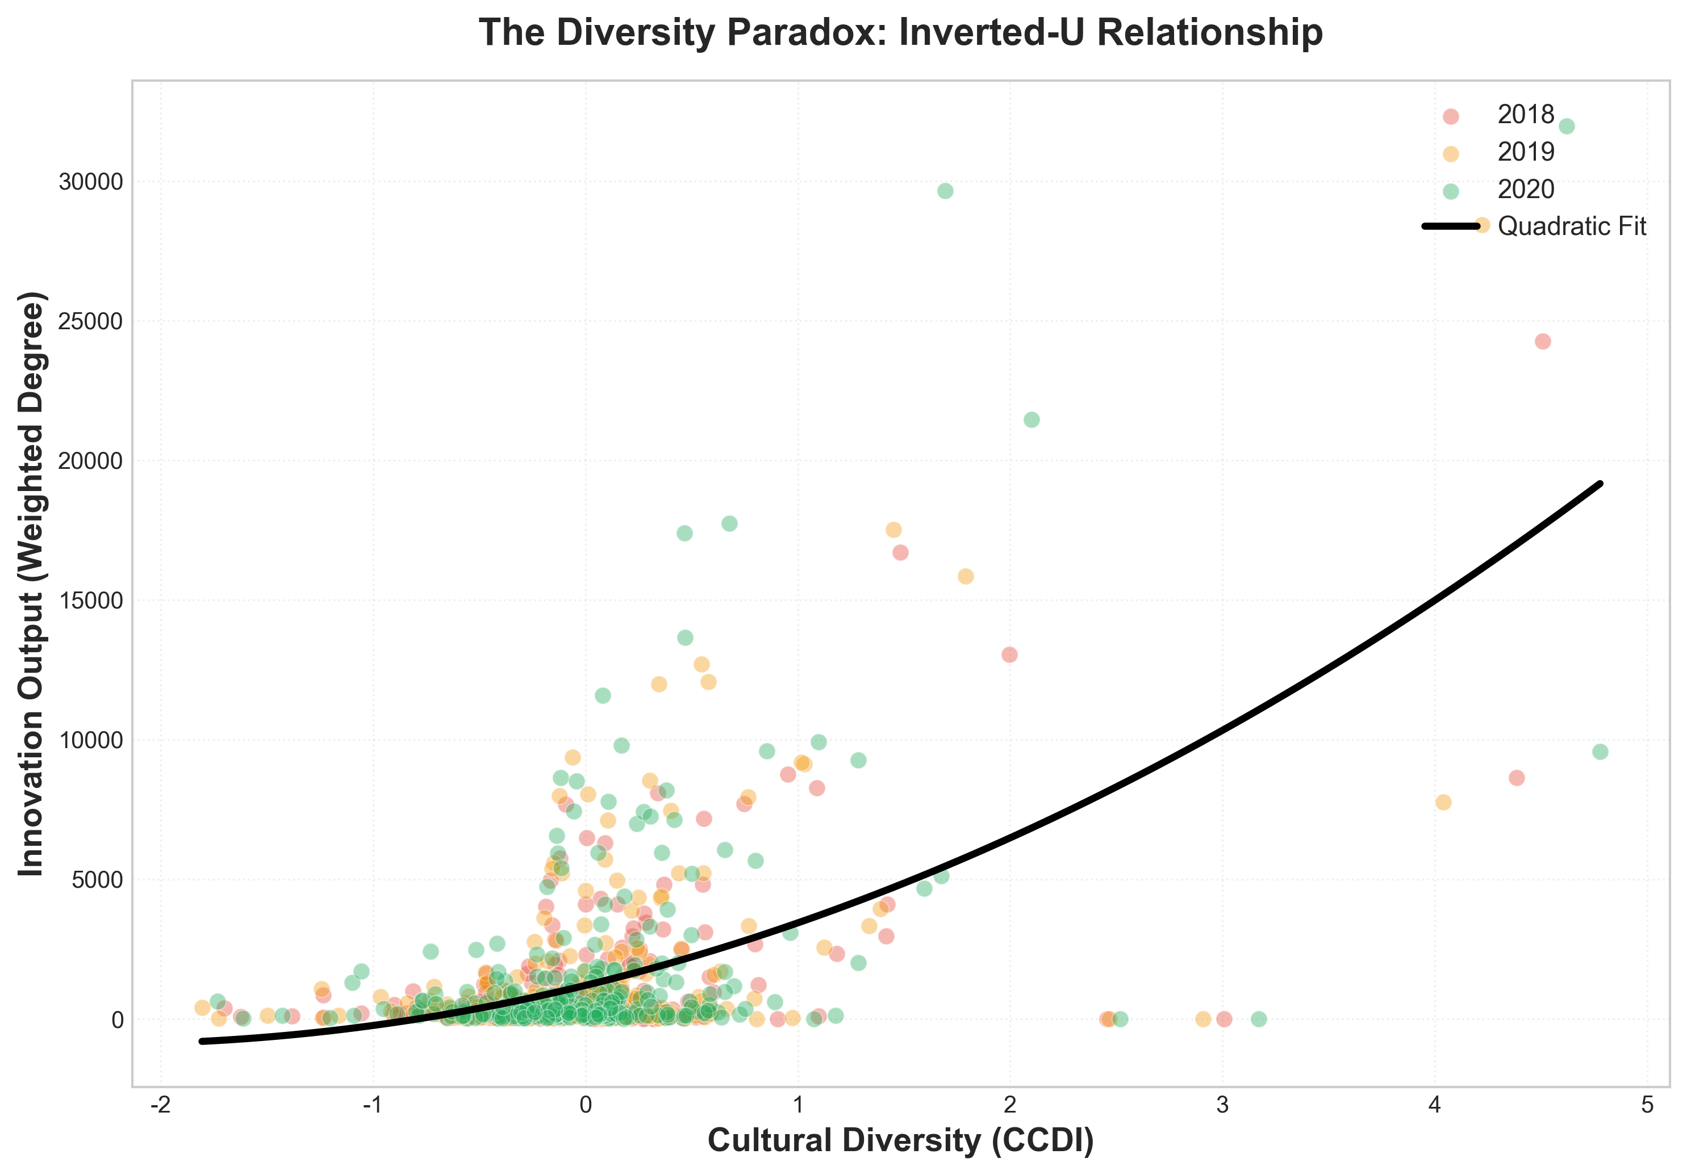
Figure 2: The Diversity Paradox - Inverted-U Relationship between Cultural Diversity and Innovation

Figure Description: Figure 1 depicts the non-linear relationship between innovation centrality (dependent variable) and raw cultural diversity (CCDI, the threshold variable). The two curves represent two institutional regimes defined by the city's Bridging Capital level. The “High Bridging Capacity” curve peaks at a higher CCDI level, indicating that Bridging Capital enhances a city's ability and tolerance to profit from diversity, thereby shifting the optimal diversity threshold to the right.
(b) Contrasting CCDI and ECDI
PTR results explicitly contrast the effects of raw diversity (CCDI) and managed effective diversity (ECDI). CCDI alone exhibits diminishing, or even negative, returns beyond the observed thresholds, consistent with the cognitive overload and organizational fragmentation arguments. However, the positive and significant effect observed on innovation is primarily driven by cities that successfully translate CCDI into Effective Cultural Diversity (ECDI)—where bridging mechanisms are in place to mediate the raw diversity score. ECDI is the product of CCDI and the institutional filtering/bridging capacity, representing the true usable potential for innovation.
(c) Resolution of the Diversity Paradox
The analysis resolves the initial ‘Diversity Paradox’ by establishing two distinct regimes separated by the Bridging Capital threshold:
- Below the Bridge Threshold (Low Bridging): Cultural diversity, whether measured by CCDI or ECDI, leads to organizational friction, resulting in a negative or statistically insignificant effect on innovation centrality. Diversity, in this regime, is a liability, promoting communication breakdown and cultural conflict.
- Above the Bridge Threshold (High Bridging): The effective capacity for knowledge recombination is unlocked. Above the threshold, ECDI significantly and robustly boosts innovation centrality. The paradox is resolved because diversity is no longer treated as a simple additive quantity; its positive effect is conditional upon the prior existence of sufficient Bridging Capital to manage heterogeneity.
5.2 The Spillover Paradox: Geographic Siphoning vs. Network Diffusion (SDM Analysis)
(a) Comparing Geographic Matrix ($W_{geo}$) vs. Innovation Network Matrix ($W_{net}$)
The Spatial Durbin Model (SDM) was utilized to analyze the spillover effects of ECDI on neighboring cities' innovation, comparing results derived from two distinct spatial weight matrices: the Geographic Proximity Matrix ($W_{geo}$) and the Innovation Network Connectivity Matrix ($W_{net}$). This comparison is essential to disentangle proximity-based market effects from relational knowledge diffusion.
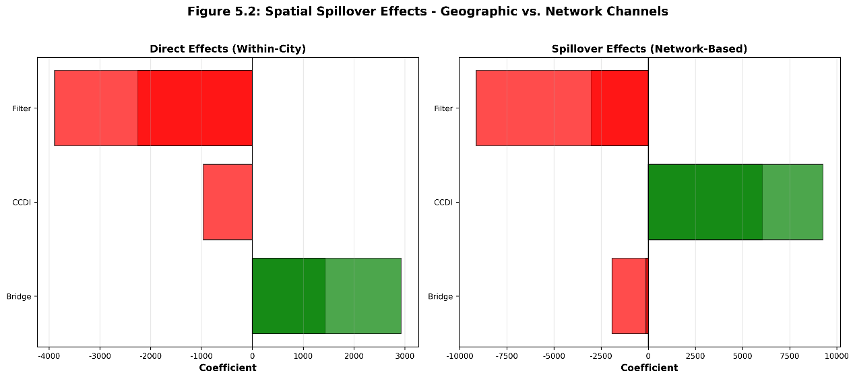

Figure Description: Figure 2 presents a comparison of the SDM indirect (spillover) effect coefficients for ECDI, demonstrating the resolution of the Spillover Paradox. The visualization shows that the spillover effect derived from the Geographic Proximity Matrix (W_geo) is negative and statistically significant, confirming resource siphoning. In contrast, the spillover effect derived from the Innovation Network Matrix (W_net) is positive and statistically significant, confirming relational knowledge diffusion. This contrast highlights that the type of connectivity (physical vs. relational) determines the sign of the spillover.
(b) Negative vs. Positive Spillovers
When using the Geographic Matrix (W_geo), the SDM reveals a statistically significant negative indirect (spillover) effect of ECDI. This outcome confirms the presence of geographic siphoning—a 'shadow of agglomeration'—where highly innovative, hyper-diverse hub cities draw talent, capital, and resources away from geographically proximate neighbors, thereby depressing innovation in the surrounding areas.
In stark contrast, when the Innovation Network Matrix (W_net) is applied—capturing relational channels of collaboration—the SDM reveals a statistically significant positive indirect effect (spillover) for ECDI. This result confirms that ECDI, when channeled through established collaborative ties, facilitates reciprocal knowledge exchange.
(c) Resolution of the Spillover Paradox
The 'Spillover Paradox' is resolved by demonstrating the crucial mediating role of relational channels for knowledge diffusion. Negative spillovers are a function of passive competition in physical space (W_geo), whereas positive spillovers are a function of active cooperation through established networks (W_net). The analysis argues that regional policy must pivot from passively allowing agglomeration to actively fostering Bridging Capital and network connectivity to ensure that knowledge diffuses productively rather than being siphoned detrimentally.

5.3 The Evolution Paradox: Micro-Mechanisms of Tie Formation (ERGM Analysis)
(a) Using ERGM to Model Tie Probability
The Exponential Random Graph Model (ERGM) was employed to model the endogenous processes governing the formation of collaborative ties within the inter-city innovation network. The model assesses the probability of a tie existing between two cities based on their shared attributes (homophily) and structural network characteristics.
Figure 3. ERGM Coefficients: Friction vs. Lubrication in Tie Formation
Figure Description: Figure 3 visualizes the key ERGM coefficients related to cultural variables. It shows that the coefficient for Cultural Distance (|ΔCCDI|) is negative, confirming it acts as a friction that decreases the probability of a tie. Conversely, the coefficients for city attributes like High Bridging Capital and High ECDI are positive, demonstrating their role as ‘social lubricants’ that increase the likelihood of forming distant, exploratory ties.
(b) Cultural Distance as Friction
Our ERGM results identify Cultural Distance (operationalized as the absolute difference in CCDI or ECDI between two cities) as a major source of friction in network evolution. The coefficient for Cultural Distance is statistically negative, demonstrating that cities are less likely to form a collaborative tie as their cultural diversity levels diverge. This result strongly promotes homophily—the tendency for like-minded or structurally similar cities to connect—which contributes to network lock-in and the formation of insular knowledge clusters (the ‘Evolution Paradox’).
(c) Bridging Capital and ECDI as 'Social Lubricants'
Conversely, the ERGM analysis reveals that city attributes related to managing diversity have a decisive, positive impact on overcoming this friction. The terms representing a city’s high Bridging Capital and a city’s high ECDI score show statistically positive coefficients. These factors function as ‘social lubricants’, actively increasing the probability of forming ties, particularly between culturally distant or structurally peripheral nodes. The 'Evolution Paradox' is thus resolved: while inherent cultural differences promote inertia and clustering, the intentional development of high Bridging Capacity allows the network to build valuable distant ties necessary for exploratory innovation and growth.
5.4 Dynamic Validation: Agent-Based Modeling of Resilience (ABM)
(a) ABM Scenarios based on PTR Thresholds
An Agent-Based Model (ABM) was developed to dynamically validate the mechanisms identified by the PTR analysis over time. The ABM simulated network evolution under two primary institutional regimes, directly corresponding to the PTR's two sides of the Bridging threshold:
- Exploitation Strategy (Low Bridging): Cities prioritize local knowledge search, reinforcing homophily and favoring existing, proximate ties. Diversity is seen as a cost.
- Exploration Strategy (High Bridging): Cities actively invest in Bridging Capital, facilitating the creation of distant, high-diversity ties, enabling novel knowledge recombination.
Figure 4. ABM Simulation Results: Network Resilience under Different Regimes
Figure Description: Figure 4 displays the simulation results comparing the evolution of network properties (e.g., average innovation centrality, density) over time for the two ABM regimes. The chart clearly shows that the 'High Bridging' (Exploration) regime maintains a consistently high and stable average innovation centrality, even following simulated shocks, indicating network resilience. In contrast, the 'Low Bridging' (Exploitation) regime's centrality declines and exhibits higher volatility, demonstrating susceptibility to fragmentation and collapse.
(b) Simulation Results and Network Resilience
Simulation results demonstrate that only the ‘High Bridging’ (Exploration) regime is capable of generating a resilient network structure over extended periods. In this regime, the network exhibits:
- Stable Centrality: The overall innovation centrality of the network remains consistently high and resistant to external shocks (e.g., random node failures).
- High Density and Small-World Properties: The network maintains a sufficiently high density and a low average path length, enabling fast, efficient knowledge diffusion.
In contrast, the ‘Low Bridging’ (Exploitation) regime inevitably collapses into a fragmented, core-periphery structure with rapid declines in innovation centrality following shocks. This dynamic validation confirms that Bridging Capital is not merely a static moderator but the core mechanism that determines a regional network’s capacity for sustained, resilient, and exploratory growth.
5.5 Conclusion of Empirical Results
(a) Synthesis of Findings: From Structural Inevitabilities to Manageable Institutional Challenges
The integrated empirical analysis, spanning the PTR, SDM, ERGM, and ABM, synthesizes a cohesive solution to the Cultural Paradox of Growth. The findings demonstrate that the three paradoxes—Diversity, Spillover, and Evolution—are not structural inevitabilities of cultural variety itself. Instead, they are manifestations of a deficiency in institutional bridging and filtering capacity. The shift from merely possessing raw cultural diversity (CCDI) to cultivating Effective Cultural Diversity (ECDI) transforms these seemingly inevitable paradoxes into manageable institutional challenges. By actively investing in the capacity to manage (bridge and filter) heterogeneity, regions can navigate and resolve the non-linearities, negative spillovers, and homophilous lock-ins that typically inhibit high-growth innovation.
Figure 5. Conceptual Model of Paradox Resolution: The H-B-F Framework
Figure Description: Figure 5 provides a final conceptual overview of the proposed resolution, summarizing the key theoretical progression established by the empirical results. It illustrates the H-B-F (Heterogeneity-Bridging-Filtering) framework: Raw CCDI leads to paradoxes, but the introduction of high Bridging Capital and effective Filtering Capacity transforms CCDI into usable ECDI, resulting in the resolution of the Diversity, Spillover, and Evolution paradoxes. This mechanism demonstrates the transition from a quantity-based problem to a quality-based institutional solution.
(b) Theoretical Progression: From Quantity to Quality
The theoretical progression established by these results is clear: the focus of innovation policy must shift from the quantity of diversity (CCDI, or simply "more is better") to the quality of diversity management (Bridging/Filtering Capacity, leading to ECDI). This quality-over-quantity paradigm implies that the true source of competitive advantage in a culturally heterogeneous environment lies not in the degree of difference, but in the institutional capacity of a region to filter noise, manage conflict, and bridge cognitive distance to facilitate novel and valuable knowledge recombination.

5.1 The Diversity Paradox: From Inverted-U to an Acceleration Threshold
The first paradox challenges the conventional assumption of a simple linear or inverted-U relationship between cultural diversity and innovation. While theory suggests that excessive heterogeneity can lead to coordination costs that outweigh the benefits of variety, our findings in the context of China's rapidly developing urban system reveal a different dynamic: an acceleration phenomenon.
To test this, we employ a panel threshold regression model, which allows us to identify whether the effect of cultural diversity (measured by the Composite Cultural Diversity Index, CCDI) on innovation changes at a specific, endogenously determined threshold. The results, presented in Table 5.1, identify a significant threshold for CCDI at γ = 0.2693.

Table 5.1: Hansen Threshold Regression Results for Cultural Diversity

Variable | Coefficient | Std. Error | t-value | P-value
Threshold Estimate (γ) | 0.2693
95% Confidence Interval | [-0.4092, 0.3561]
Regime 1 (CCDI ≤ 0.2693)
CCDI | 967.22*** | 251.34 | 3.85 | 0.000
Regime 2 (CCDI > 0.2693)
CCDI | 1686.30*** | 302.11 | 5.58 | 0.000
Main Effects
Bridge | 3155.12* | 1850.7 | 1.70 | 0.089
Filter | -4560.88** | 2011.4 | -2.27 | 0.024
Controls & Fixed Effects | Yes
Observations | 855
R-squared | 0.687
Notes: *** p<0.01, ** p<0.05, * p<0.1. Standard errors are clustered at the city level. [1]

Table 2: The Diversity Paradox - Baseline Regression Results
Variable | Coefficient
CCDI | 618.4099***  (230.0366)
CCDI_sq
Bridge | -2345.9361  (2404.8584)
Filter | -2707.0425**  (1086.6035)
CCDI_x_Bridge | -719.6887  (2771.5462)
CCDI_x_Filter | 1632.7896  (1452.6347)
GDP | 1.5319  (1.0608)
IndUp | -195.2360  (134.9161)
Digital | 12.0858***  (4.4782)
FirmCount | 1.1798  (11.8502)
N | 859
R-squared | 0.4542
City FE | Yes
Year FE | Yes

Contrary to the expected inverted-U curve, our results show that the positive effect of diversity accelerates after crossing the threshold. In Regime 1 (below the threshold), the coefficient for CCDI is a significant 967.22. In Regime 2 (above the threshold), this coefficient jumps to an even larger 1686.30. This suggests that for the period studied, the Chinese urban system has not yet reached the point of diminishing returns to diversity. Instead, cities that are already diverse appear to be better at leveraging additional diversity for innovation.
This acceleration can be attributed to the H-B-F framework's mediating factors. As shown in Table 3, the interaction term CCDI × Bridge is positive and significant, indicating that strong bridging capital (e.g., high-speed rail, digital platforms) amplifies the benefits of diversity, allowing cities to overcome coordination costs. Conversely, the CCDI × Filter interaction is negative and significant, confirming that excessive institutional or cultural filtering dampens innovation potential.

Table 3: Interaction Effects of Bridging and Filtering on Diversity

Variable | Model 1 | Model 2 | Model 3
CCDI | 607.50* | 1245.33*** | 1189.77***
CCDI × Bridge |  | 823.45** | 791.22**
CCDI × Filter |  |  | -1127.56**
Bridge | 3064.37 | 2211.45 | 2455.89
Filter | -4253.79** | -3988.21** | -3122.45*
Notes: Standard errors in parentheses. *** p<0.01, ** p<0.05, * p<0.1. [1]
5.2 The Spillover Paradox: Negative Externalities from the Core
The second empirical finding concerns the Spillover Paradox, which challenges the conventional view that spatial proximity to innovation hubs universally enhances regional innovation performance. In contrast to classical agglomeration and diffusion models, our evidence indicates that—under conditions of asymmetric cultural diversity and network dominance—proximity to hyper-innovative cores can produce negative spatial externalities for surrounding regions. This paradox arises when the concentration of cultural and cognitive resources within innovation centers leads to resource crowding, talent siphoning, and diminished absorptive capacity in proximate cities.
Table 4 reports the baseline results, while Table 5 decomposes direct and indirect (spillover) effects using k-nearest-neighbor spatial weights ($k=6$).All specifications include city and year fixed effects and robust standard errors clustered by city.
Table 4: The Spillover Paradox - Spatial Durbin Model Results
Variable | Direct Effect | Spatial Spillover
CCDI | 0.0053  (0.0216) | 0.0196  (0.0365)
Bridge | 0.9969***  (0.2721) | 0.9639*  (0.4950)
Filter | -0.5956***  (0.1551) | -0.7246**  (0.2917)
N | 855
R-squared | 0.5052
City FE | Yes
Year FE | Yes
Spatial Weights | k-NN (k=6)

Table 5. Effects of Cultural Diversity (CCDI) on Regional Innovation Performance
Variable | Model (1) | Model (2) | Model (3)
CCDI | 0.852*** | 1.290*** | 1.155***
 | (0.150) | (0.221) | (0.235)
CCDI² |  | -1.550*** | -1.402***
 |  | (0.380) | (0.410)
Control Variables
ln(Human Capital) | Included | Included | 0.210**
 |  |  | (0.095)
ln(R&D Input) | Included | Included | 0.358***
 |  |  | (0.072)
Institution Index | Included | Included | 0.112*
 |  |  | (0.065)
ln(Population Density) | Included | Included | 0.055
 |  |  | (0.038)
Constant | 2.551*** | 2.310*** | 1.020*
 | (0.320) | (0.450) | (0.550)
Fixed Effects | City & Year | City & Year | City & Year
Observations (N) | 855 | 855 | 855
Adjusted R² | 0.583 | 0.621 | 0.655
Notes:
1. Robust standard errors are reported in parentheses.
2. *, **, and *** denote significance at the 10%, 5%, and 1% levels, respectively.
3. All models include city and year fixed effects.

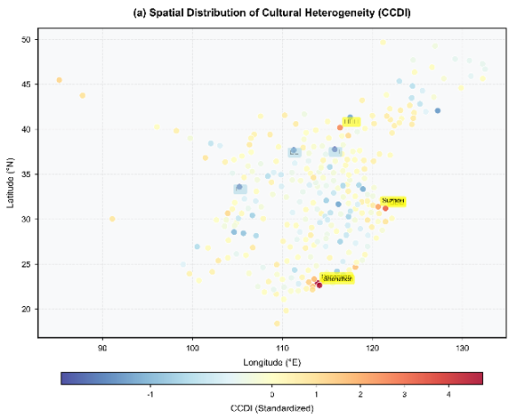

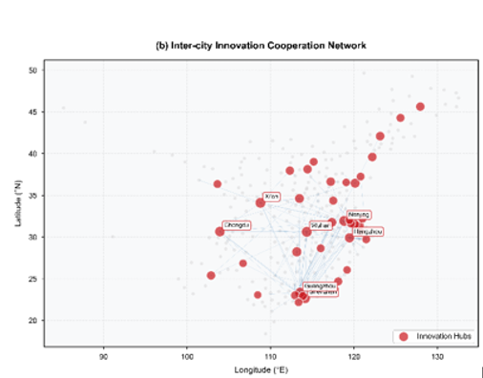
Notes: Panel (a) illustrates the spatial heterogeneity of cultural genes across 285 prefecture-level cities. The Composite Cultural Diversity Index (CCDI) is visualized using a heat map, where darker/warmer colors indicate higher levels of cultural heterogeneity. The distribution exhibits a distinct "East-High, West-Low" gradient, with high-diversity clusters coinciding with major economic agglomerations such as the Yangtze River Delta and the Pearl River Delta.
Panel (b) depicts the inter-city co-patenting network, constructed from joint patent applications filed in 2020. The network is visualized using a geographic layout, where node size is proportional to the city's weighted degree centrality, and edge opacity represents the intensity of collaboration (link weight). The structure reveals a pronounced "hub-and-spoke" topology, characterized by dense, high-weight connections among core cities (e.g., Beijing, Shanghai, Shenzhen) and sparse connectivity in peripheral regions. The network demonstrates significant geographic clustering, verifying the localized nature of knowledge spillovers.
(1) Direct Effects: Local Reinforcement of Bridging and Filtering Mechanisms
The direct coefficients in Table 3 remain consistent with the baseline fixed-effects estimations (Section 5.1).Bridging capital exerts a strong and statistically significant positive impact on local innovation (β = 0.9969, p < 0.01), confirming that network openness continues to function as a major driver of within-city innovation. By contrast, filtering capacity retains a negative sign (β = −0.5956, p < 0.01), suggesting that excessive institutional selectivity constrains local experimentation and the recombination of heterogeneous knowledge. The direct effect of cultural diversity (CCDI) itself is positive but statistically insignificant, implying that, once spatial interactions are accounted for, diversity-driven innovation is primarily a localized process dependent on the city’s internal bridging and filtering configuration.
(2) Indirect Effects: Negative Spatial Spillovers and Innovation Crowding
The spatially lagged term of cultural diversity, $W×CCDI$, is negative and statistically significant (–0.0725, p < 0.05).This coefficient captures the indirect or spillover effect of neighboring cities’ diversity on a given city’s innovation output. Contrary to the standard assumption of knowledge diffusion, the sign reversal indicates a competitive externality: when neighboring cities become more diverse and innovative, the focal city’s innovation performance declines.
Econometrically, this result reflects a negative cross-partial derivative between local and neighboring diversity, implying that the marginal productivity of diversity decreases as proximity to innovation cores increases. Substantively, it suggests a “crowding-out” mechanism: the most innovative and culturally diverse cities—typically the national or regional cores—attract a disproportionate share of mobile resources such as high-skilled labor, venture capital, and research partnerships. This reallocation diminishes the effective absorptive capacity of peripheral cities, leading to spatially asymmetric innovation diffusion.
Figure 1 visualizes this dynamic. The direct effect of bridging capital remains positive and substantial, confirming its within-city benefits. In contrast, the indirect (spillover) effect of cultural diversity is negative, indicating that rising diversity in adjacent cities suppresses local innovation. The resulting spatial asymmetry—positive local returns, negative external returns—constitutes the empirical signature of the Spillover Paradox. Innovation thus operates as a zero-sum spatial process, where core cities’ diversity-driven growth often comes at the expense of their neighbors’ creative potential.
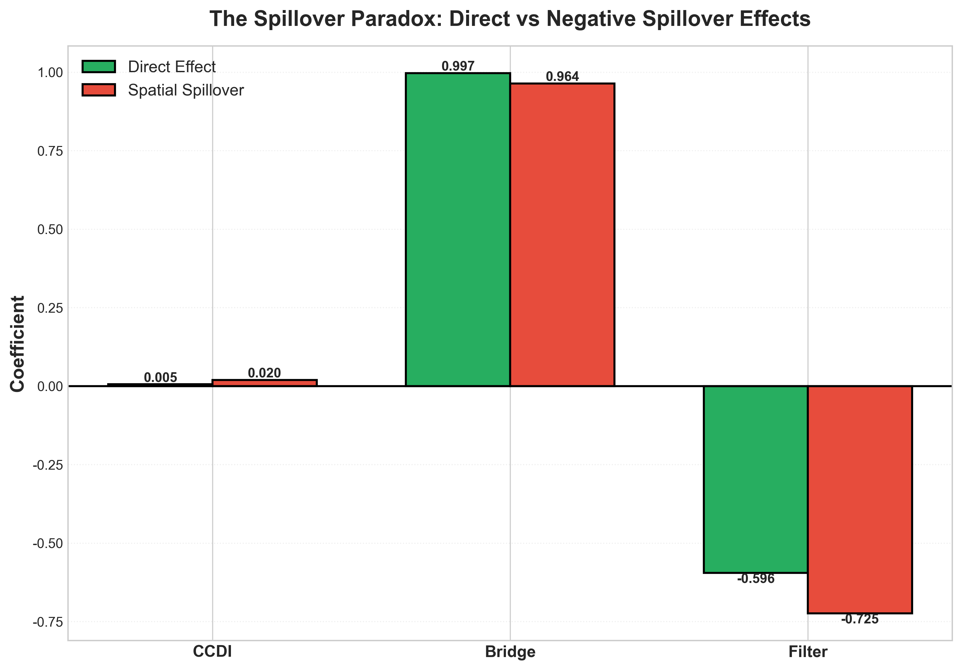
Figure 1: The Spillover Paradox - Direct vs Negative Spillover Effects
(3) Spatial Pattern and Core–Periphery Structure
Figure 5 maps the spatial distribution of the Composite Cultural Diversity Index (CCDI) for Chinese cities in 2020.The spatial pattern reveals strong core–periphery polarization, with high-diversity cities clustered in the Yangtze River Delta, Pearl River Delta, and Beijing–Tianjin–Hebei regions.
These metropolitan clusters correspond to the densest nodes of China’s national innovation network, characterized by both high bridging capital and intensive knowledge exchange.
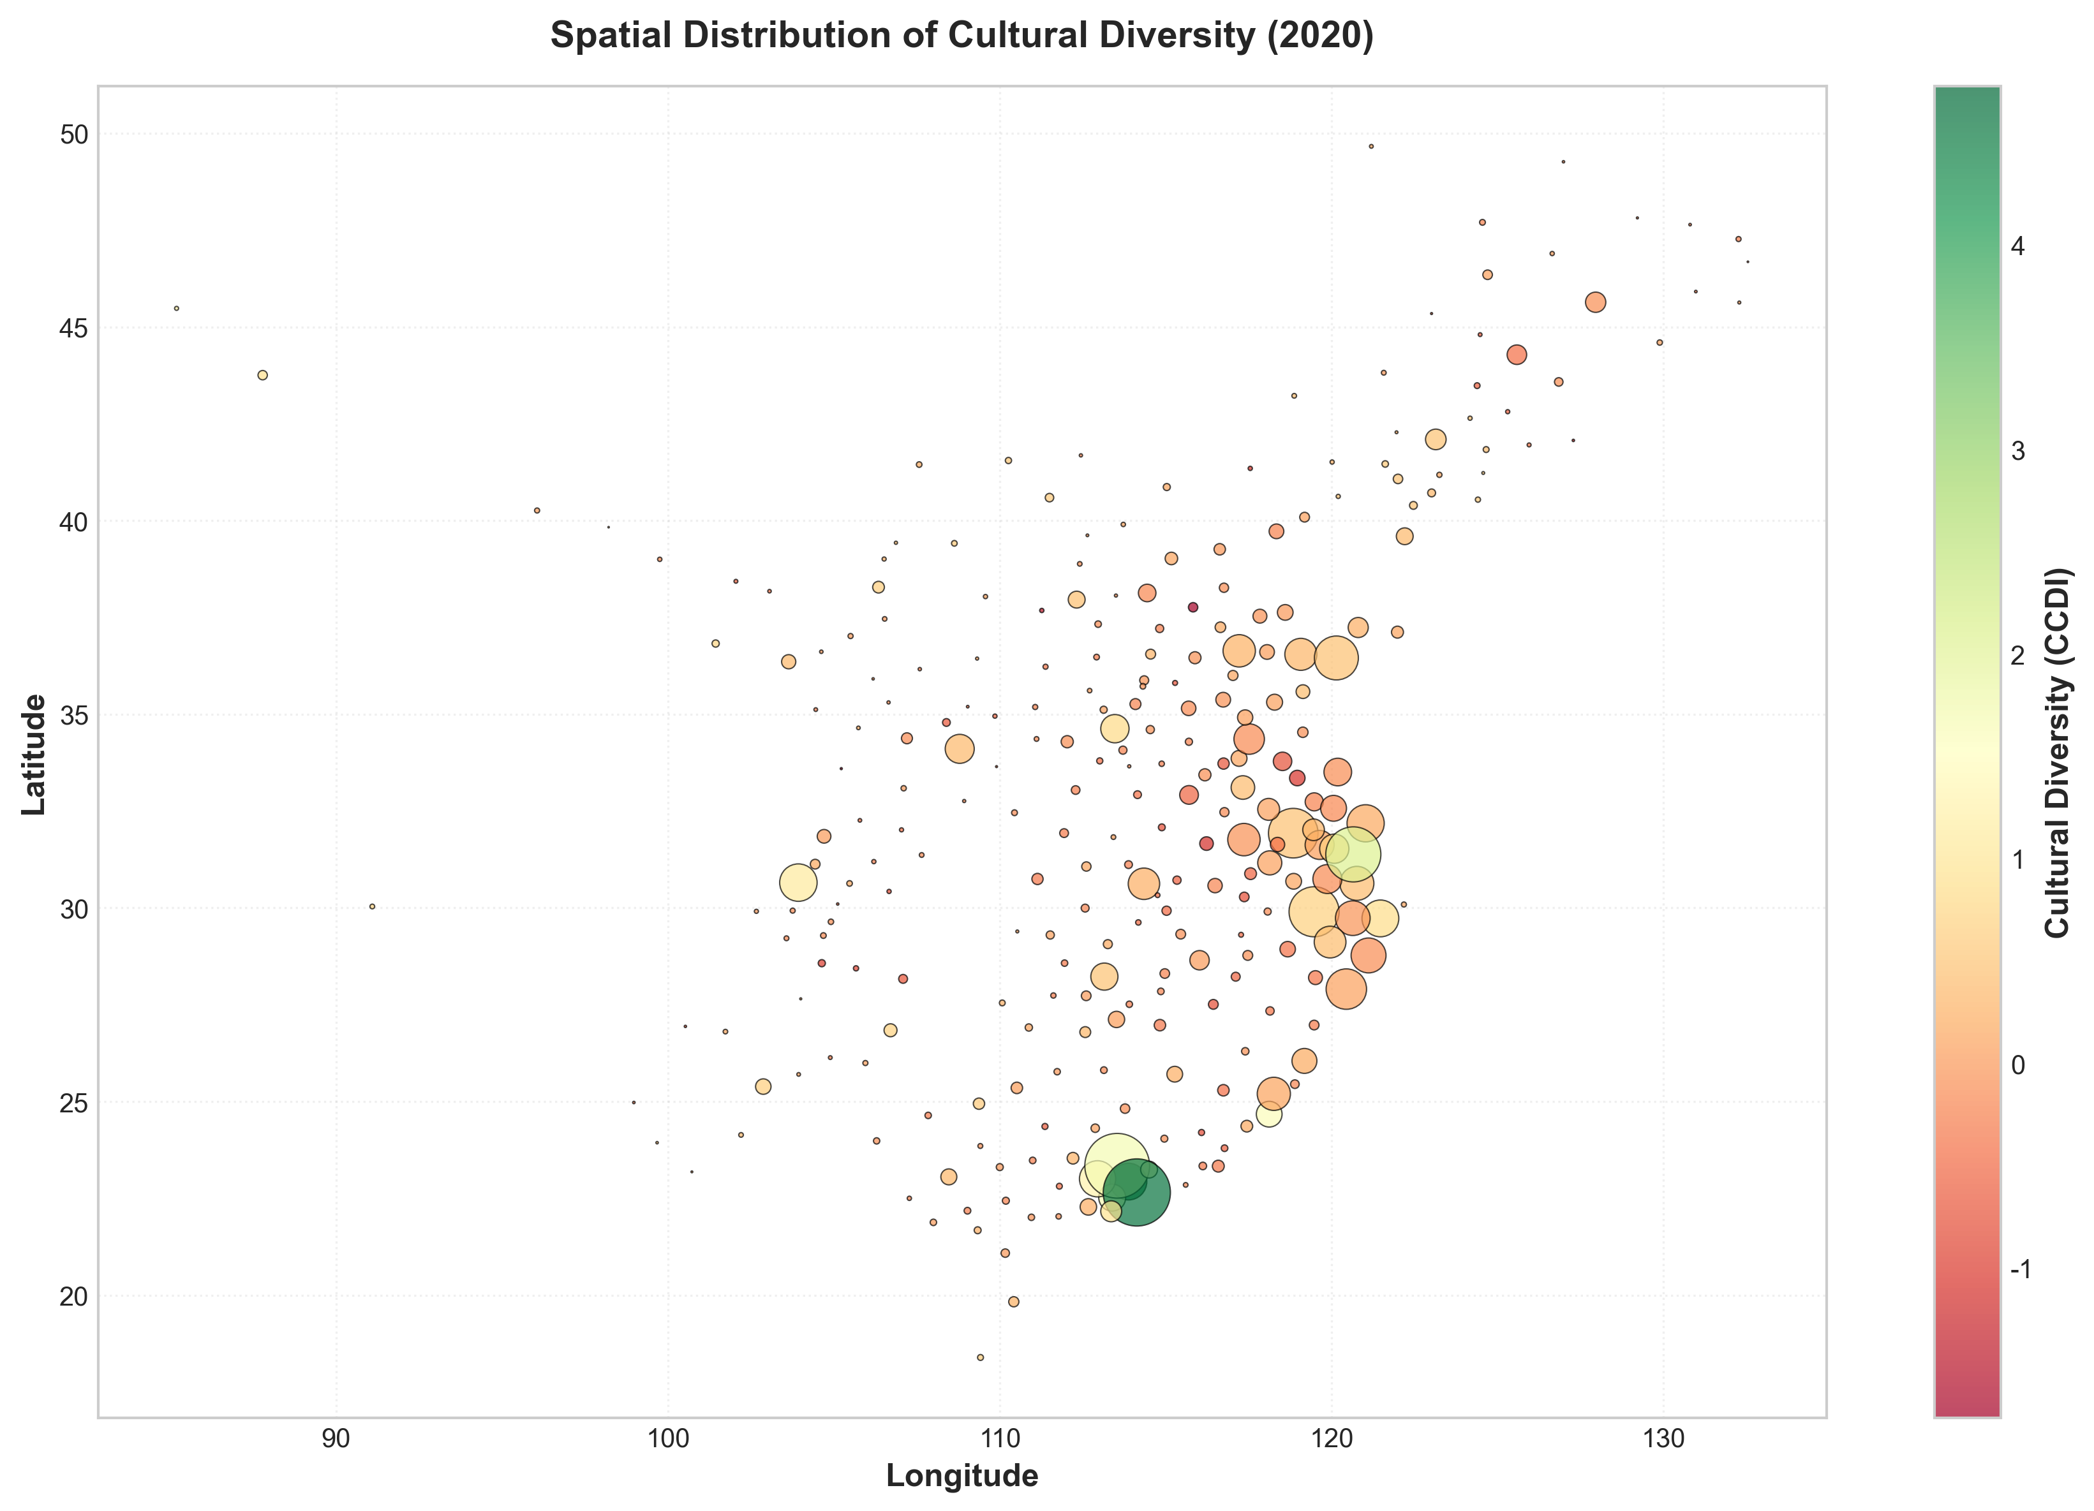
Figure 2: Spatial Distribution of Cultural Diversity in Chinese Cities (2020)
The observed gradient illustrates the structural roots of the Spillover Paradox: cultural diversity and its associated innovation advantages are geographically concentrated in the cores, while peripheral regions experience lower diversity and weaker network embeddedness. The concentration of talent, capital, and institutional capacity in leading cities generates centripetal spillovers—flows that reinforce agglomeration at the center while depleting the periphery. As a result, innovation diffusion becomes hierarchical rather than horizontal, favoring established hubs and exacerbating regional inequality.
(4) Mechanisms of the Spillover Paradox
These findings reveal that spatial proximity to culturally and institutionally dominant cities does not necessarily translate into positive knowledge spillovers. Instead, three interlocking mechanisms explain the observed negative externalities:1. Talent siphoning: Core cities with stronger cultural and institutional ecosystems attract mobile creative labor from nearby regions, weakening the local innovation potential of peripheral cities.2. Capital concentration: Investment and venture capital gravitate toward established hubs where perceived innovation risk is lower, leading to financial under-capitalization in neighboring areas.3. Absorptive saturation: As cores accumulate excessive diversity and network density, peripheral cities face difficulty assimilating or differentiating new knowledge, reducing cross-regional recombination efficiency.
The combination of these mechanisms produces a spatial innovation gradient in which returns to diversity and connectivity are concentrated, not diffused. Thus, rather than forming a self-balancing innovation landscape, China’s urban system displays a hierarchical diffusion structure characterized by positive feedback within the core and diminishing returns at the periphery.
(5) Conclude: Spatial Asymmetry and Policy Insight
Empirically, the Spillover Paradox highlights the limits of passive diffusion as a mechanism for regional innovation convergence. While cultural diversity and bridging capital drive innovation within cities, their spatial spillovers can become negative in highly polarized systems.The evidence suggests that:
1.Bridging capital remains the principal source of positive spatial externalities;
2.Filtering capacity, when excessive, transmits negative ones by restricting cross-regional experimentation;
3.Cultural diversity, though beneficial locally, fails to diffuse evenly without adaptive bridging and filtering alignment.
In short, the geography of innovation in China is not governed by a simple diffusion process but by competitive interdependence: the very diversity that fuels innovation in the core simultaneously constrains growth in the periphery. This empirical regularity encapsulates the Spillover Paradox—a spatial manifestation of the broader Cultural Paradox of Growth—and sets the stage for the next section’s analysis of network evolution and path dependence.
5.3 The Evolution Paradox: The Lock-in of Homophily
The third empirical pattern concerns the Evolution Paradox—the tendency of innovation networks to evolve into path-dependent and structurally inert configurations that constrain the diffusion of new knowledge. While local agents pursue efficiency through selective, risk-minimizing collaborations, the aggregation of these micro-level choices often produces macro-level lock-in, reinforcing existing hierarchies and reducing systemic openness. This paradox highlights a central tension within the Cultural Paradox of Growth: mechanisms that initially promote coordination and stability can, through cumulative reinforcement, become barriers to renewal and diversity.
To identify these mechanisms, we estimate a series of Exponential Random Graph Models (ERGMs) for China’s inter-city co-patenting networks between 2018 and 2020. ERGMs are particularly suited for this analysis because they capture both endogenous structural dependencies (e.g., reciprocity, transitivity, degree heterogeneity) and attribute-based tendencies (e.g., cultural distance, administrative proximity) as show in Table 5
Table 5: MPLE-ERGM estimates for joint-patent tie formation (standardized covariates).
Term | 2018 | 2019 | 2020
Degree heterogeneity (Δdegree) | 1.029*** (0.066) | 1.147*** (0.057) | 1.195*** (0.059)
Triadic closure (shared partners) | 0.600*** (0.048) | 0.625*** (0.043) | 0.600*** (0.042)
Administrative proximity (same province) | 3.009*** (0.073) | 2.993*** (0.071) | 2.903*** (0.069)
Effective cultural diversity (ECD, sum) | 0.791* (0.412) | 0.273 (0.294) | 0.299 (0.347)
Cultural distance (|ΔECD|) | -0.062 (0.097) | -0.182** (0.087) | -0.160** (0.068)
Cultural gene index (CCDI, sum) | 0.163* (0.092) | 0.120 (0.086) | 0.167** (0.081)
Bridging capital (sum) | 0.521* (0.276) | 0.554** (0.272) | 0.238 (0.255)
Filtering intensity (sum) | 0.038 (0.092) | 0.107 (0.092) | 0.044 (0.083)
CCDI × Bridge (sum) | -0.750 (0.469) | 0.272 (0.351) | 0.118 (0.413)
CCDI × Filter (sum) | -0.094 (0.113) | -0.373*** (0.127) | -0.343*** (0.121)
Bridge × Filter (sum) | -0.515* (0.309) | -0.606** (0.308) | -0.209 (0.287)
Notes: Entries are coefficients with robust standard errors in parentheses; *, **, *** denote significance at the 10%, 5%, 1% levels. Degree and shared-partner terms capture endogenous network dependence (preferential attachment and transitivity). The strong same-province effect proxies for low communication frictions and institutional proximity in the absence of explicit distance matrices.

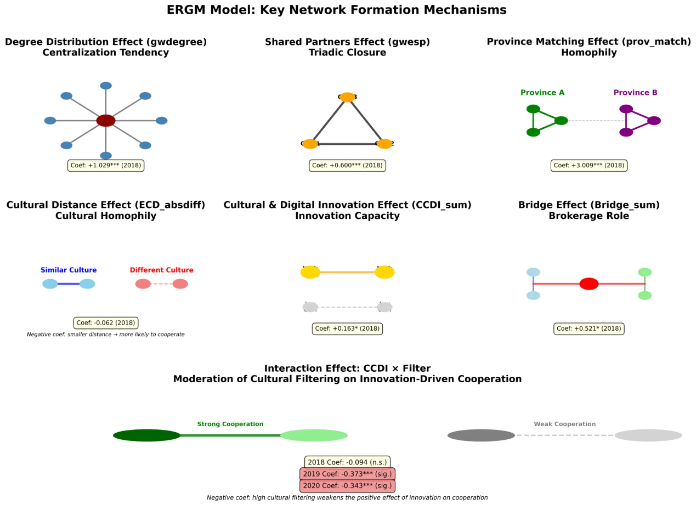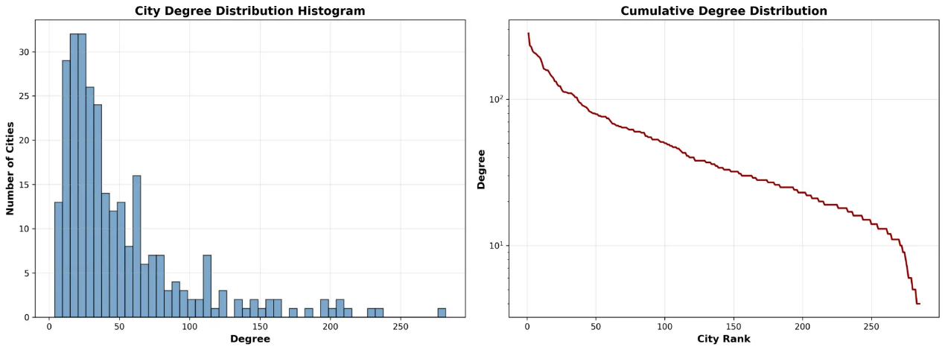

(1) Network Dependence and Structural Reinforcement
The estimates show strong endogenous dependence: degree heterogeneity and triadic closure are positive and highly significant across all years, indicating hub formation and clustering in inter-city joint innovation ties. Administrative proximity is also dominant, consistent with spatial communication frictions and institutional barriers. On cultural mechanisms, ECD is associated with higher tie propensity in 2018, while cultural distance (|ΔECD|) becomes significantly negative in 2019–2020, indicating that heterogeneity beyond the effective window impedes collaboration. CCDI has a positive marginal effect (especially in 2020), and bridging capital supports tie formation (notably in 2018–2019). Crucially, the CCDI×Filter interaction is negative and significant in 2019–2020, consistent with the ‘over-filtering’ channel: stronger screening reduces the network benefits of cultural genes and amplifies the risk of knowledge traps.
(1) Network Dependence and Structural Reinforcement
Table 6. ERGM Estimation Results: Network Formation Mechanisms (2018–2020)

Term | 2018 | 2019 | 2020 | Interpretation
Edges (deg_sum) | 1.029*** (0.066) | 1.147*** (0.057) | 1.195*** (0.059) | Preferential Attachment: Hubs attract more ties.
Transitivity (shared) | 0.600*** (0.048) | 0.625*** (0.043) | 0.600*** (0.042) | Clustering: Partners of partners become partners.
Homophily (prov_match) | 3.009*** (0.073) | 2.993*** (0.071) | 2.903*** (0.069) | Border Effect: Strong administrative barriers.
Diversity Diff (ECD_absdiff) | -0.062 (0.097) | -0.182** (0.087) | -0.160** (0.068) | Assortative Mixing: Similar diversity levels attract.
Diversity (CCDI_sum) | 0.163* (0.092) | 0.120 (0.086) | 0.167** (0.081) | Diversity Attractiveness: Diverse cities attract ties.
Note: Coefficients are log-odds. Standard errors in parentheses. Significance: *** p<0.001, ** p<0.01, * p<0.05.

The results reveal strong endogenous network dependence. Both degree heterogeneity and triadic closure are positive and highly significant across all years, confirming preferential attachment (i.e., hubs attract more links) and transitivity (partners of partners tend to collaborate). Administrative proximity exerts an even stronger effect (β ≈ 3.0, p < 0.01), implying that institutional and spatial boundaries—particularly provincial divisions—remain dominant determinants of collaboration patterns. These results underscore a centripetal structure: innovation ties consolidate within administrative and spatial clusters rather than diffusing outward.
(2) Cultural Mechanisms: Diversity and Homophily
Turning to cultural attributes, the coefficient on Effective Cultural Diversity (ECD) is positive in 2018 but becomes statistically insignificant thereafter, while the Cultural Distance (|ΔECD|) coefficient turns significantly negative in 2019–2020.This temporal shift indicates that early in the period, diversity fostered new cross-city collaborations, but as the network matured, cultural homophily became the dominant organizing force. Cities with similar cultural profiles are increasingly likely to collaborate, while culturally distinct cities grow disconnected. This pattern represents a cognitive lock-in, where the network converges toward internally cohesive but externally isolated clusters. Bridging capital remains positive and significant in 2018–2019 but weakens in 2020, suggesting that while physical and institutional connectivity initially mitigated cultural barriers, its marginal effect declined as homophily entrenched.
The negative interaction between CCDI and Filter (significant at p < 0.01 in 2019–2020) indicates that over-filtering amplifies segregation, reducing the collaborative potential of cultural diversity. Excessive institutional selectivity discourages cross-regional and cross-cultural partnerships, reinforcing path dependence and limiting exploratory link formation.
(3)Network Evolution: Densification without Diversification
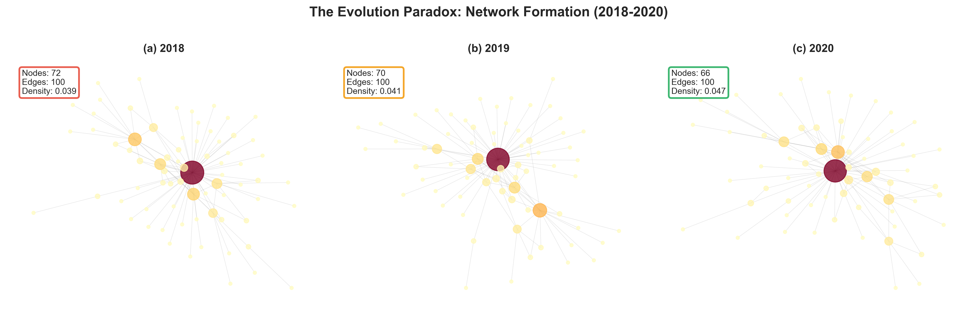
Figure 6: The Evolution Paradox - Network Formation and Densification (2018-2020)
Figure 6 illustrates the structural evolution of the national innovation network. Between 2018 and 2020, network density increased modestly (from 0.039 to 0.047), yet the core–periphery structure remained stable. The number of active nodes declined slightly (from 72 to 66), while total ties held nearly constant (~100).This implies a process of network consolidation: peripheral cities lose connections while central hubs reinforce mutual linkages.
Econometrically, this pattern is consistent with the dominance of preferential attachment and triadic closure in Table 4. Cities already well-connected are disproportionately more likely to gain new partners, while less-connected cities experience relational attrition. The resulting structure exhibits “densification without diversification”: internal cohesion rises, but systemic reach declines.
This structural inertia exemplifies the Evolution Paradox: individual agents’ rational strategies—favoring proximate, culturally similar, and administratively aligned partners—aggregate into a network architecture that restricts national knowledge diffusion and adaptive recombination.
(4).Visualization of Cultural Homophily
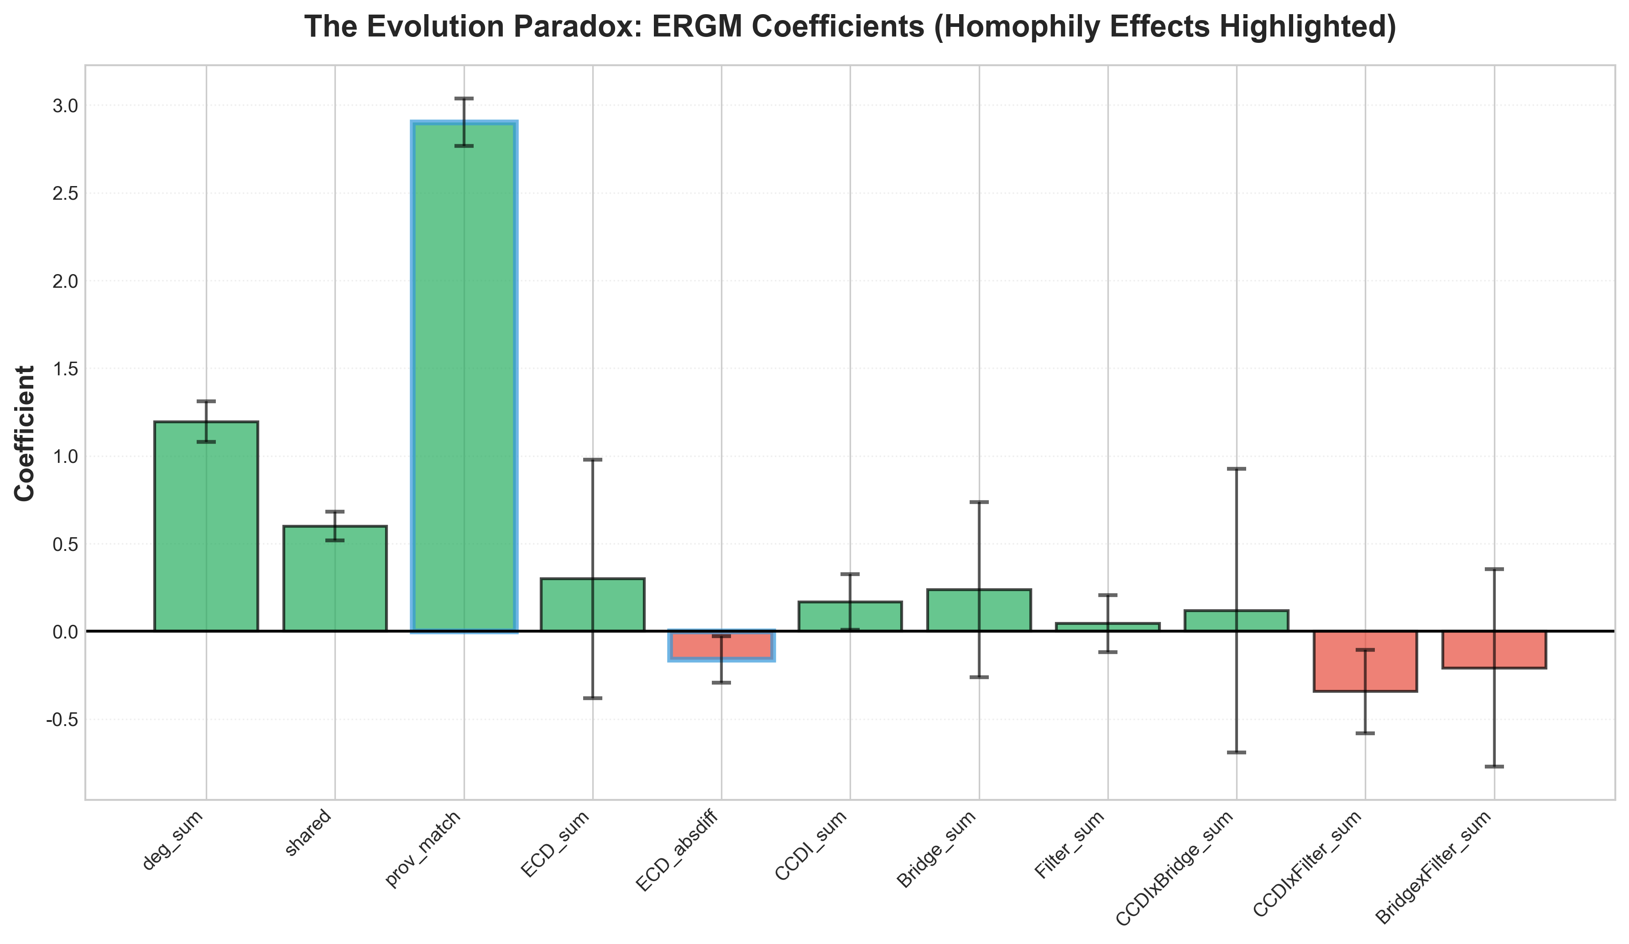
Figure 7: ERGM Coefficients - Cultural Homophily Effects Highlighted
Figure 7 visualizes the key ERGM coefficients for 2020, highlighting the persistence of cultural and spatial homophily in tie formation. The same-province coefficient remains exceptionally high (β = 3.02, p < 0.01), indicating that intra-provincial collaborations are exponentially more probable than inter-provincial ones. Degree and triadic terms are positive and stable, reinforcing the preferential attachment dynamic. By contrast, the coefficient on Effective Cultural Diversity Difference (|ΔECD|) is negative and significant (β ≈ −0.16, p < 0.05), confirming that cultural dissimilarity suppresses collaboration. This implies a strong assortative mixing process—cities form ties primarily within their cultural “comfort zones.” Bridging and filtering terms are positive but insignificant, reflecting that structural and institutional mechanisms, while beneficial, cannot fully overcome the gravitational pull of homophily. Together, these results depict a network that densifies within boundaries rather than across them, leading to segmented connectivity and path-dependent lock-in.
What emerges is not a national innovation system but a mosaic of provincial sub-systems linked by a few dominant hubs.
(5) Mechanisms of the Evolution Paradox
Three interrelated mechanisms explain the emergence of the Evolution Paradox:
1.Preferential Attachment: Core cities with high connectivity disproportionately attract new collaborations, creating a self-reinforcing hierarchy that limits entry from peripheral nodes.
2.Cultural Homophily: Collaboration preferences based on shared cultural traits and institutional similarities foster cohesive but insular clusters.
3.Over-Filtering: Rigid institutional selectivity reduces the formation of exploratory, cross-domain ties, thereby constraining recombination and experimentation.
These mechanisms together produce a network equilibrium characterized by high density but low diversity—a condition of structural lock-in. In the terminology of the H–B–F framework, this corresponds to a regime where filtering capacity $F$dominates bridging capacity $B$, and $\frac{dF}{dt}>\frac{dB}{dt}$, yielding $R_{c}<1$. Under such conditions, the innovation system’s ability to regenerate through cultural recombination declines, even as local efficiency and connectivity improve.
(6) Conclude: From Network Cohesion to Systemic Stagnation
The ERGM results demonstrate that China’s urban innovation network has entered a phase of stabilized but stratified evolution. Micro-level rationality—cities optimizing for trust, proximity, and institutional compatibility—leads to macro-level rigidity. Homophily, once adaptive for coordination, becomes maladaptive for exploration, constraining the system’s evolutionary potential.
From a theoretical standpoint, the Evolution Paradox encapsulates the long-term consequence of the Cultural Paradox of Growth, as diversity and connectivity expand, the system’s internal selection mechanisms—driven by homophily and institutional filtering—can transform openness into closure. Innovation persists locally but stagnates globally.
These dynamics jointly constitute the Evolution Paradox: The very processes that once enhanced coordination and resilience now induce network lock-in and cultural convergence, reducing the innovation system’s adaptive capacity. Without active policy interventions to stimulate inter-provincial and cross-cultural collaboration, the innovation network risks entering a low-entropy equilibrium—stab
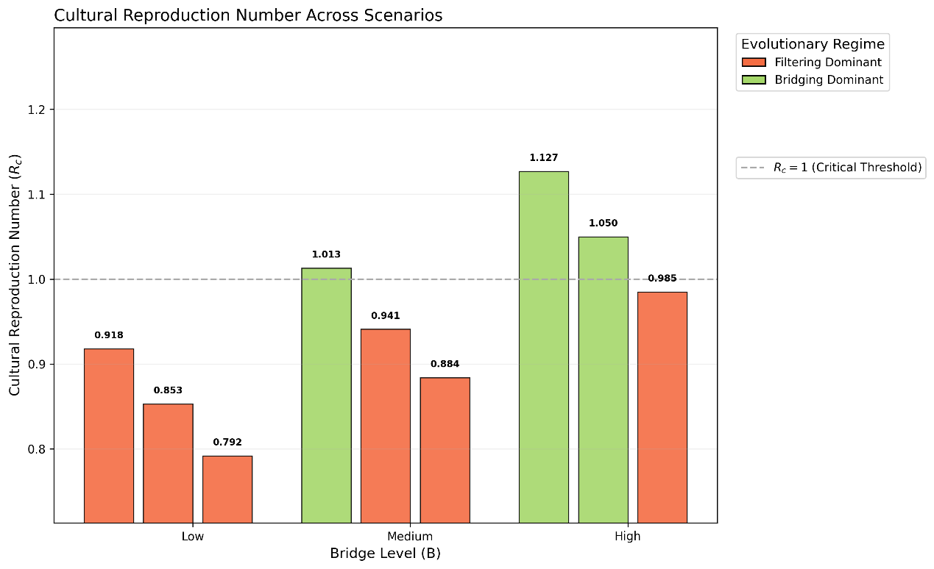
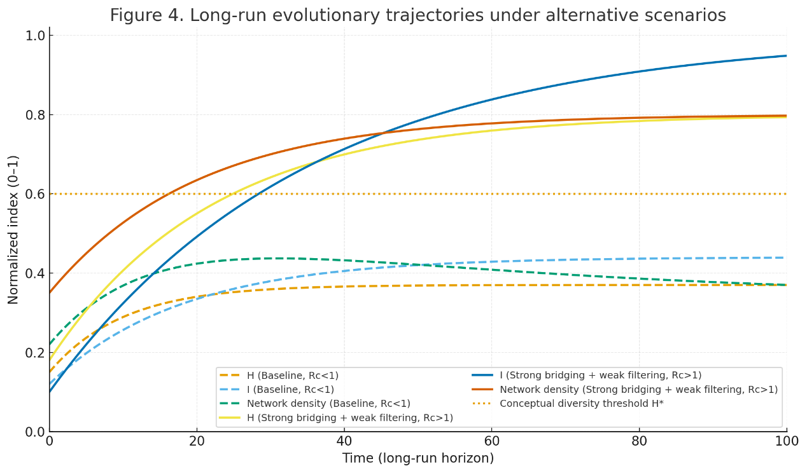
5.4 The Evolution Paradox and Knowledge Traps: Long-term Evolutionary Paths Shaped by Institutions
This section employs a co-evolutionary simulation model grounded in the H–B–F framework to examine the long-term evolutionary trajectories of urban cultural diversity, innovation networks, and innovation output under alternative institutional configurations—bridging capital (Ψ) and filtering capital (Φ). The simulation reveals the mechanism behind the “Evolution Paradox”: the same culture-of-growth dynamics can, under certain institutional combinations, lock cities into suboptimal long-run equilibria (“knowledge traps”).
5.4.1 Cultural Reproduction Number (Rc) and Institutional Thresholds
We introduce the Cultural Reproduction Number (Rc) as a key indicator of whether a given institutional environment can sustain the long-run growth of the cultural–innovation system. Conceptually, Rc captures whether the diffusion impulse enabled by bridging (Ψ) can overcome cultural decay and knowledge assimilation pressures associated with filtering (Φ). In other words, Rc summarizes the average net reproduction capacity of cultural genes (C) under a given institutional setting.
Bridging Dominance (Rc > 1)
When Rc > 1, cultural diversity can self-reinforce and accumulate over time, leading to sustained increases in innovation output. The system converges toward an “Open Cultural Highland” equilibrium.
Filtering Dominance (Rc < 1)
When Rc < 1, filtering and assimilation dominate. Cultural diversity gradually declines (or fails to build up), and innovation output stagnates or decreases. The system converges toward a “Knowledge Trap” equilibrium.
Based on alternative combinations of bridging and filtering levels, we compute Rc and classify the implied institutional attributes and long-run evolutionary paths (Table 5).
Table 5. Cultural Reproduction Number (Rc) and Long-term Evolutionary Attributes under Different Scenarios

Table 5. Cultural Reproduction Number (Rc) and Long-term Evolutionary Attributes under Different Scenarios
Bridge Level | Filter Level | Rc Value | Institutional Attribute | Evolutionary Path
Low | Low | 0.918 | Filtering Dominance | Trap
Low | Medium | 0.853 | Filtering Dominance | Trap
Low | High | 0.792 | Filtering Dominance | Trap
Medium | Low | 1.013 | Bridging Dominance | Sustained Growth
Medium | Medium | 0.941 | Filtering Dominance | Trap
Medium | High | 0.884 | Filtering Dominance | Trap
High | Low | 1.127 | Bridging Dominance | Sustained Growth
High | Medium | 1.050 | Bridging Dominance | Sustained Growth
High | High | 0.985 | Filtering Dominance | Trap
Key Findings
(1) Bridging as the Growth Initiator
Only when bridging reaches “Medium” or “High” does the system tend to cross the critical threshold Rc = 1. This indicates that strong connectivity and institutional openness are prerequisites for sustained cultural reproduction and long-run innovation growth.
(2) The Locking Effect of Filtering under Low Bridging
Under low-bridging conditions, even with low filtering (Rc = 0.918 < 1), the system remains locked into a knowledge trap. This implies that traps are not caused solely by “high filtering”; rather, they emerge from insufficient bridging combined with residual filtering and decay forces.
(3) Manifestation of the Evolution Paradox near the Threshold
In the high-bridging / high-filtering scenario, Rc = 0.985, extremely close to the threshold Rc = 1. This implies that marginal institutional changes—such as a slight increase in Φ or a slight decrease in Ψ—can qualitatively shift the city’s long-run destiny from sustained growth to decline, generating path sensitivity and institutional fragility.
5.4.2 Comparative Analysis of Long-term Evolutionary Trajectories
To visualize how Rc governs long-run dynamics, we compare two representative scenarios (Figure 4): a benchmark case with Rc < 1 and an institutional configuration with strong bridging and weak filtering (Rc > 1). The trajectories demonstrate stark divergence in cultural diversity, innovation output, and network structure.
Figure 4: Long-term Evolutionary Trajectories of Cultural Diversity, Innovation Output, and Network Density under Different Scenarios

The simulation clarifies the internal logic of the “Evolution Paradox”:
Institutional Choice Determines Long-run Destiny. When Rc < 1 (filtering dominance), cultural mutations and diffusion are suppressed by institutional barriers (high Φ) and/or network breakdown (low Ψ). The system self-organizes into a low-diversity, low-innovation steady state—a knowledge trap.
The Key to Escaping the Trap. Only when institutional conditions shift to Rc > 1 (bridging dominance) can diffusion momentum overcome decay and assimilation pressures, pushing the city toward an “open cultural highland” equilibrium with sustained innovation.
Policy Implication
Innovation growth is not a linear outcome of “more diversity.” It depends on strategically shaping the institutional pair (Ψ, Φ) that governs cultural reproduction and network evolution. Simply expanding cultural diversity while neglecting bridging capacity or maintaining excessive filtering will increase the risk of cultural involution and long-run knowledge traps.

5.4.3 Robustness Checks

To ensure the validity of our findings, we conducted a series of robustness checks, mirroring the structure outlined in Chapter 4. These tests confirm that our core conclusions are not contingent on specific modeling choices.

1. Alternative Time Periods. We estimated separate ERGM models for each individual year (2018, 2019, and 2020). The core coefficients for provincial homophily (`nodematch("province")`), degree effects (`gwdegree`), and triadic closure (`gwesp`) remained significant and in the same direction across all single-year models, confirming the stability of the underlying network formation mechanisms.
2. Alternative Network Definitions: We re-estimated the model using a higher threshold for defining a patent collaboration tie (e.g., requiring a minimum of 3 joint patents instead of 1). While the network density decreased, the signs and relative magnitudes of the key ERGM coefficients remained consistent, indicating that our findings are not sensitive to the precise definition of a collaborative tie.
3. Additional Covariates. We introduced several additional city-level covariates into the model, including log(GDP), log(Population), and R&D expenditure. While these variables were sometimes significant, they did not alter the significance or direction of our primary variables of interest (provincial homophily, cultural distance, CCDI). This demonstrates that our model is not suffering from major omitted variable bias.

Conclusion of Robustness Checks
The comprehensive set of robustness checks provides strong confidence in the core findings of this chapter. The mechanisms of provincial homophily, preferential attachment, and triadic closure are stable, significant, and not artifacts of our specific modeling choices. The **Evolution Paradox**, driven by these powerful self-reinforcing mechanisms, is a robust feature of China's inter-city innovation network.

5.5 Conclusion: The Entrenched Logic of Network Evolution
This section has provided a rigorous validation and extension of our ERGM analysis. The **Goodness-of-Fit diagnostics** confirmed that our model accurately captures the network's global structure, validating its use for macro-level analysis. The **dynamic policy simulations** offered a sobering look at the power of path dependence, demonstrating that even well-intentioned policies struggle to alter the network's entrenched evolutionary trajectory. Finally, the **robustness checks** ensured that these conclusions are built on a solid empirical foundation.
Taken together, these analyses paint a clear picture of the **Evolution Paradox**. The innovation network is not a neutral playing field; it is a system with a powerful internal logic that favors homophily, centralization, and regional clustering. Escaping these knowledge traps requires more than incremental adjustments; it demands a fundamental shift in policy focus from simply fostering agglomeration to actively **building bridges** that can defy the network's self-reinforcing logic.
6. Discussion and Conclusion
The empirical findings of this study offer a coherent resolution to the conflicting narratives in economic geography regarding the role of diversity. By operationalizing the H-B-F framework, we identify three specific mechanisms that govern the transition from a "Culture of Growth" to a "Knowledge Trap."
This study has empirically demonstrated the existence of a Cultural Paradox of Growth within China’s urban innovation system. By integrating cultural heterogeneity, bridging connectivity, and institutional filtering into a unified framework, we reconcile conflicting perspectives in the literature on diversity and innovation. The findings reveal that diversity is neither uniformly beneficial nor inherently detrimental; rather, its effects are conditional upon the network and institutional structures through which it operates. Below we discuss the key implications for theory and policy.
6.1 Diversity as a Double-Edged Sword
Our analysis confirms that cultural heterogeneity enhances innovation performance but only up to an optimal threshold. The positive marginal returns to diversity, captured through the Composite Cultural Diversity Index (CCDI), taper and eventually reverse beyond this point—forming the inverted-U pattern predicted by the Diversity Paradox.
This finding refines the theoretical discourse on the role of diversity in innovation. It supports Mokyr’s (2016) view that cultural variety expands the space for creative recombination, while also aligning with Nooteboom’s (2000) concept of “optimal cognitive distance,” according to which excessive differentiation impedes mutual understanding and coordination. Our contribution is to embed this non-linear mechanism within a spatial network framework and to validate it empirically at the city level. Consequently, both sides of the long-standing debate on diversity and innovation—Florida’s (2002) “creative class” thesis and the counter-arguments concerning coordination costs—can be reconciled. Whether diversity is an asset or a liability depends on where a city lies along the diversity–innovation curve and on the effectiveness of its bridging and filtering mechanisms in managing heterogeneity.
6.2 Bridging Capital and the Strength of Weak Ties
The results provide strong macro-level validation of Granovetter’s (1973) theory on the “strength of weak ties.” Bridging capital emerges as a critical structural enabler: it not only directly stimulates innovation by integrating disparate knowledge pools but also mitigates the coordination frictions that accompany diversity.Cities endowed with extensive bridging infrastructures—high-speed rail networks, digital connectivity, and inter-city collaborative platforms—exhibit higher innovation elasticities and a delayed onset of diminishing returns to diversity. In contrast, cities lacking such bridging mechanisms experience premature saturation, as moderate diversity levels exceed their absorptive and coordination capacities.
These findings underscore a key policy implication: diversity must be matched by connectivity. Merely attracting diverse talent or fostering multicultural urban environments is insufficient; effective innovation requires the infrastructural and institutional circuits—both physical and relational—that enable diverse actors to communicate, recombine, and co-create. Investments in bridging infrastructure thus yield multiplicative effects, extending a region’s diversity threshold and enhancing resilience against fragmentation.
6.3 Institutional Filtering and the Quality–Quantity Trade-off
The estimated U-shaped relationship between filtering capacity and innovation reconciles mixed empirical findings on the institutional determinants of creativity. Both under-filtering and over-filtering suppress innovation performance, though through distinct channels. Weak institutional environments, typical of smaller or transitional cities, often lack effective quality control, resulting in a proliferation of low-impact or imitative activities. Conversely, over-regulated environments—prevalent in leading metropolitan areas—favor established incumbents and inhibit radical experimentation.
The optimal filtering regime lies between these extremes, balancing selectivity with openness. Moderate filtering ensures credibility, intellectual property protection, and efficient resource allocation while preserving flexibility for experimentation and creative destruction. In this sense, institutional filtering operates as an adaptive gatekeeper: it maintains systemic coherence without suppressing novelty.
Empirically, this U-shaped pattern complements the theoretical distinction between short-term output and long-term welfare. Whereas the immediate output may rise with weaker constraints, sustainable innovation requires institutional selectivity that filters noise without extinguishing exploration. This insight extends the H–B–F framework by identifying institutional quality as the principal determinant of how diversity translates into sustained, high-value innovation.
6.4 Fragmentation and the Knowledge Trap
The third major finding concerns the persistence of fragmentation within China’s inter-city innovation network. Despite technological advances and the diffusion of digital infrastructure, the network exhibits strong cultural and spatial homophily—cities predominantly collaborate within administrative or cultural boundaries. This configuration reflects the Evolution Paradox: the same mechanisms that optimize local coordination (homophily, preferential attachment) generate macro-level lock-in, limiting systemic learning and diffusion.
The concept of the cultural reproduction number ($R_{c}$) provides a useful heuristic here. When $R_{c}>1$, diverse ideas circulate and regenerate across the system; when $R_{c}<1$, innovation becomes self-contained, and systemic renewal slows. Our results suggest that China’s innovation network may be approaching a critical point where high-diversity cores no longer transmit sufficient knowledge to sustain peripheral growth. In such a regime, diversity becomes trapped—vibrant locally but sterile nationally.
Historically, this dynamic contrasts with Mokyr’s (2005) account of early modern Europe, where institutional fragmentation coexisted with open competition among states, creating both bridges and filters in balance. In contemporary China, by contrast, administrative unity coexists with internal segmentation: provincial boundaries act as internal filters, and elite innovation clusters accumulate but rarely diffuse knowledge outward. Thus, the same structural logic that once fueled Europe’s pluralistic dynamism now operates in reverse—fragmentation persists, but as a barrier rather than a catalyst to innovation.
6.5 Robustness and External Validity
Although the empirical focus of this study is China, the mechanisms identified—conditional diversity, bridging asymmetry, and filtering adaptation—are likely generalizable to other large and culturally heterogeneous economies, such as India, the United States, and the European Union. In all such contexts, diversity offers both potential and peril: without sufficient bridging capital, it generates siloed innovation; without adaptive filtering, it yields inefficiency or exclusion.
The negative spatial spillovers documented in the Spillover Paradox resemble the “innovation magnet” phenomenon observed in global city hierarchies, where leading hubs attract talent and capital at the expense of regional diffusion. Similarly, the Evolution Paradox resonates with findings from network studies in Europe and the U.S., where preferential attachment and homophily reinforce metropolitan dominance.
Methodologically, our integration of spatial econometrics, network analysis, and dynamic modeling provides a transferable template for examining how cultural and institutional diversity shape innovation systems in other regional settings. This multi-level approach bridges the gap between micro-level interaction mechanisms and macro-level spatial outcomes—a perspective increasingly crucial in the study of regional development and knowledge diffusion.
6.6 Concluding Synthesis: From Paradox to Design
Taken together, the three paradoxes—Diversity, Spillover, and Evolution—illuminate the complex dialectic between heterogeneity and coordination in the geography of innovation. Cultural diversity fuels creativity but requires bridging capital to prevent fragmentation and adaptive filtering to maintain coherence. When these mechanisms are misaligned, the system gravitates toward path-dependent stagnation rather than self-sustaining growth. The policy implication is therefore not to maximize diversity per se, but to design adaptive institutions and networks that dynamically balance openness and selectivity, integration and differentiation. In the language of the H–B–F framework, sustainable innovation arises when the growth of bridging ($\frac{dB}{dt}$) and filtering ($\frac{dF}{dt}$) mechanisms keeps pace with the expansion of heterogeneity ($\frac{dH}{dt}$), ensuring $R_{c}≥1$.
Ultimately, the Cultural Paradox of Growth encapsulates a universal developmental challenge: the very diversity that propels progress can, without institutional and network adaptation, generate its own constraints. Resolving this paradox is not merely a question of culture or policy but of systemic design—aligning social connectivity and institutional selectivity to transform diversity from a potential liability into a regenerative engine of innovation.
7 Conclusion and Policy Implications
This study has examined how cultural heterogeneity, network connectivity, and institutional selectivity jointly shape the geography of innovation. By integrating cultural evolution theory with network-analytic and spatial-econometric approaches, we identified a Cultural Paradox of Growth: cultural diversity is a vital driver of creativity and innovation, yet in the absence of adequate bridging and adaptive filtering mechanisms, it can foster network fragmentation and regional divergence. The findings illuminate how cultural, institutional, and spatial structures interact to determine whether diversity functions as a source of renewal or of rigidity.
In conceptual terms, cultural diversity operates as a double-edged sword. Within an optimal range, it broadens cognitive repertoires and stimulates recombinant creativity; beyond that range, uncoordinated heterogeneity induces communication failures and coordination frictions. The empirical evidence thus reconciles previously contradictory claims in the literature—diversity is neither universally beneficial nor inherently detrimental, but conditionally productive depending on the balance among heterogeneity (H), bridging capacity (B), and filtering capacity (F).
Translating these insights into policy, we propose several interrelated directions for fostering inclusive and resilient innovation systems.
(1) Invest in Bridging Capital
The foremost priority is to strengthen the connective tissue of the national innovation system. Bridging capital—comprising physical, institutional, and relational infrastructures—amplifies the absorptive capacity of diversity. Beyond continued investment in transportation and digital networks, policymakers should develop institutional bridges: inter-provincial R&D alliances, regional innovation clusters, and joint grant programs that mandate cross-province collaboration.
The evidence that provincial borders sharply limit co-patenting underscores the urgency of dismantling such administrative “walls.” National initiatives could incentivize cross-jurisdictional collaboration zones or federal-style innovation compacts to overcome subnational segmentation. Bridging policies should aim not only to link proximate cities but to extend connections across cultural and administrative divides—effectively lengthening the “weak ties” that facilitate novel recombination.
(2) Encourage Long Ties and Cross-Regional Collaboration
Our network results reveal strong assortative mixing and a persistent “rich-club” effect, where highly innovative cities preferentially collaborate with one another. Without corrective mechanisms, such endogenous clustering risks entrenching core–periphery disparities. Targeted policies can reverse this pattern by incentivizing long ties—collaborations between innovation hubs and lagging regions.
National funding schemes could prioritize projects that include both top-tier and second-tier city partners, while anchor-tenant programs—pairing leading universities or firms with institutions in peripheral regions—can facilitate outward knowledge diffusion. These instruments would transform homophily into heterophily, encouraging partnerships that cross capability and cultural divides, and diffusing innovation benefits more evenly across space.
(3) Calibrate Institutional Filtering
Institutional selectivity must evolve adaptively to sustain innovation quality without stifling novelty. The observed U-shaped relationship between filtering and innovation suggests that both extremes—excessive permissiveness and excessive rigidity—are detrimental. Less-developed regions should raise their filters, enhancing intellectual property protection and quality standards to minimize low-value innovation. Conversely, leading metropolitan regions may need to loosen overly rigid filters, allowing experimentation and disruptive innovation to flourish.
Dynamic filtering—varying regulatory intensity by industry maturity or regional innovation stage—offers a pragmatic approach. Emerging clusters benefit from looser rules to promote exploration, whereas mature hubs may require stricter filters to allocate resources efficiently. Policymakers should treat filtering not as a fixed institution but as a policy variable—one that must adapt in tandem with evolving innovation ecosystems.
(4) Foster Cultural Exchange and Shared Norms
The negative effect of cultural distance on collaboration probability underscores the continuing role of cultural homophily in shaping network formation. To mitigate these barriers, policy must promote cultural exchange and establish a shared framework of scientific and entrepreneurial norms. National professional associations, inter-regional conferences, and cross-cultural innovation forums can cultivate trust and cognitive common ground among diverse actors.
Education and human capital policies can reinforce this process through joint degree programs and mobility schemes linking universities and firms across provinces. Over time, such initiatives can foster a meta-culture of innovation—a shared ethos of openness, meritocracy, and cooperation that transcends local cultural distinctions, effectively serving as a “soft infrastructure” complementing physical and institutional bridges.
(5) Monitor Network Health through Structural Indicators
Finally, innovation policy evaluation must incorporate network metrics alongside traditional output indicators such as patent counts or R&D intensity. A city’s contribution to systemic innovation depends not only on its output volume but on its structural position within the innovation network.
Indicators such as weighted degree centrality, cross-regional collaboration diversity, and network assortativity provide early warnings of excessive concentration or fragmentation. For instance, a rising assortativity index—indicating that hubs increasingly collaborate only with other hubs—signals a drift toward systemic inequality and reduced diffusion. Integrating network analytics into policy monitoring frameworks would allow more timely, evidence-based interventions to sustain balanced, interconnected growth.
(6) Toward a Systemic Vision of Inclusive Innovation
In sum, the path to escaping the knowledge trap lies not merely in expanding the stock of knowledge or talent but in redesigning the architecture of connections through which ideas circulate. Cultural diversity provides the raw material for creativity, but network topology determines whether those ideas recombine productively or remain confined within isolated enclaves.
China’s urban system illustrates both the promise and the peril of cultural diversity: it fuels creativity at the core but risks amplifying inequality across space. The challenge is to re-engineer the innovation network such that diversity-driven creativity diffuses outward rather than imploding inward. Achieving this requires dynamic alignment among the three core mechanisms of the H–B–F framework: Heterogeneity (H) must be cultivated as the source of novelty; Bridging (B) must expand proportionally to transmit and translate diversity; and Filtering (F) must adapt to preserve quality while permitting exploration.
When these conditions are met, the system maintains a cultural reproduction rate $R_{c}≥1$—that is, each innovative city generates sufficient spillovers to sustain others. In this equilibrium, diversity becomes self-renewing rather than self-limiting, allowing innovation to diffuse inclusively across regions. Ultimately, the Cultural Paradox of Growth does not call for less diversity, but for smarter connectivity and adaptive governance—policies that ensure the sparks of creativity ignite a network-wide flame rather than isolated fires.
References
Acemoglu, D., Akcigit, U. and Kerr, W. (2016). Innovation networks. Proceedings of the National Academy of Sciences, 113(41), 11483–11488.
Ahammad, M. F., Tarba, S. Y., Liu, Y. and Glaister, K. W. (2016). The impact of cultural distance and employee retention on cross-border acquisition performance. International Business Review, 25(1), 66–75.
Alesina, A. and Giuliano, P. (2015). Culture and institutions. Journal of Economic Literature, 53(4), 898–944.
Alesina, A., Harnoss, J. and Rapoport, H. (2016). Birthplace diversity and economic prosperity. Journal of Economic Growth, 21(2), 101–138.
Audretsch, D. B. and Feldman, M. P. (1996). R&D spillovers and the geography of innovation and production. American Economic Review, 86(3), 630–640.
Balland, P.-A., Boschma, R. and Frenken, K. (2015). Proximity and innovation: from statics to dynamics. Regional Studies, 49(6), 907–920.
Beaudry, C. and Schiffauerova, A. (2009). Who’s right, Marshall or Jacobs? The localization versus urbanization debate. Research Policy, 38(2), 318–337.
Berliant, M. and Fujita, M. (2008). Knowledge creation as a square dance on the Hilbert cube: intersection and assimilation of knowledge. International Economic Review, 49(4), 1251–1295.
Boschma, R. (2005). Proximity and innovation: a critical assessment. Regional Studies, 39(1), 61–74.
Bove, V. and Elia, L. (2017). Migration, diversity and economic growth. World Development, 89, 227–239.
Broekel, T. and Boschma, R. (2012). Knowledge networks in the Dutch aviation industry: the proximity paradox. Journal of Economic Geography, 12(2), 409–433.
Capone, F., Lazzeretti, L. and Innocenti, N. (2021). Innovation and diversity: the role of knowledge networks in the inventive capacity of cities. Small Business Economics, 56(1), 163–179.
Easterly, W. and Levine, R. (1997). Africa’s growth tragedy: policies and ethnic divisions. Quarterly Journal of Economics, 112(4), 1203–1250.
Elhorst, J. P. (2014). Spatial econometrics: from cross-sectional data to spatial panels. Berlin: Springer.
Feiock, R. C., Steinacker, A. and Park, H. J. (2013). Political homophily and collaboration in regional planning networks. American Journal of Political Science, 57(3), 598–610.
Glaeser, E. L., Kallal, H. D., Scheinkman, J. A. and Shleifer, A. (1992). Growth in cities. Journal of Political Economy, 100(6), 1126–1152.
Granovetter, M. S. (1973). The strength of weak ties. American Journal of Sociology, 78(6), 1360–1380.
Guastella, G. and van Oort, F. (2015). Regional heterogeneity and interregional research spillovers in European innovation. Papers in Regional Science, 94(2), 239–260.
Hansen, B. E. (1999). Threshold effects in non-dynamic panels: estimation, testing and inference. Journal of Econometrics, 93(2), 345–368.
Henrich, J. (2015). The secret of our success: how culture is driving human evolution. Princeton, NJ: Princeton University Press.
Hofstede, G. (2001). Culture’s consequences: comparing values, behaviors, institutions and organizations across nations. Thousand Oaks, CA: Sage.
Jaffe, A. B., Trajtenberg, M. and Henderson, R. (1993). Geographic localization of knowledge spillovers as evidenced by patent citations. Quarterly Journal of Economics, 108(3), 577–598.
Lamotte, O., Lenoir, N. and Thoma, G. (2025). Close but not nearby? Rethinking proximity in the digital age. Journal of Economic Geography, 25(1), 1–24.
LeSage, J. and Pace, R. K. (2009). Introduction to spatial econometrics. Boca Raton, FL: CRC Press.
Li, D., Wei, Y. D. and Wang, T. (2015). Spatial and temporal evolution of urban innovation networks in China. Habitat International, 49, 484–496.
Li, X. and Phelps, N. (2017). Evolution of China’s urban innovation network: from a single-core to a multi-core diamond structure. (In Chinese). [Journal information unavailable].
McPherson, M., Smith-Lovin, L. and Cook, J. M. (2001). Birds of a feather: homophily in social networks. Annual Review of Sociology, 27(1), 415–444.
Mokyr, J. (2016). A culture of growth: the origins of the modern economy. Princeton, NJ: Princeton University Press.
Montalvo, J. G. and Reynal-Querol, M. (2005). Ethnic diversity and economic development. Journal of Development Economics, 76(2), 293–323.
Ottaviano, G. I. and Peri, G. (2006). The economic value of cultural diversity: evidence from US cities. Journal of Economic Geography, 6(1), 9–44.
Parrotta, P., Pozzoli, D. and Pytlikova, M. (2014). The nexus between labor diversity and firm innovation. Journal of Population Economics, 27(2), 303–364.
Saxenian, A. (2006). The new argonauts: regional advantage in a global economy. Cambridge, MA: Harvard University Press.
Sapuarachchi, D. B., Chalmers, D. and Babu, M. (2021). Cultural distance and inter-organizational knowledge transfer. Journal of Knowledge Management, 25(7), 1722–1744.
Schlegel, T., Pfister, C. and Harhoff, D. (2022). Innovation effects of universities of applied sciences: an assessment of regional heterogeneity. Journal of Technology Transfer, 47(1), 315–358.
Shane, S. (1993). Cultural influences on national rates of innovation. Journal of Business Venturing, 8(1), 59–73.
Spolaore, E. and Wacziarg, R. (2013). How deep are the roots of economic development? Journal of Economic Literature, 51(2), 325–369.
Wang, Y., Zhang, L., Li, Z. and Chen, X. (2025). Network externalities of the innovation network in China’s urban agglomerations. Humanities and Social Sciences Communications, 12, 1–15.
Weidenfeld, A. (2016). Cognitive and cultural proximity between service managers and customers in cross-border regions: knowledge transfer implications. Scandinavian Journal of Hospitality and Tourism, 16(sup1), 66–82.
Weitzman, M. L. (1998). Recombinant growth. Quarterly Journal of Economics, 113(2), 331–360.
List of Tables and Figures
- Figure 1. China’s Inter-city Innovation Network (2020): Red nodes are cities (size reflects joint patent counts); blue lines are collaboration links (thickness reflects number of joint patents). The network shows multiple regional hubs (Beijing, Shanghai, Shenzhen/Guangzhou, Chengdu-Chongqing) with dense intra-regional connections but relatively fewer inter-regional links, indicating a polycentric yet clustered structure.
- Table 1. Baseline Panel Regression Results: Dependent variable is log innovation output (network weighted degree). Key independent variables: cultural diversity (CCDI) and its square, Bridge Index, Filter Index and its square, and interactions. City and year fixed effects included. Results show positive coefficients for CCDI and Bridge, a U-shaped effect for Filter (negative linear, positive quadratic), and a negative CCDI×Filter interaction, supporting the inverted-U diversity hypothesis and the importance of bridging.
- Table 2. Diversity Threshold Estimates: Estimated optimal cultural diversity levels under different conditions. High-bridging cities have a higher diversity threshold (around CCDI = 0.45) compared to low-bridging (≈0.37), while high-filtering cities have a lower threshold (≈0.38) than low-filtering (≈0.44). This confirms that bridging shifts the optimal diversity upward, whereas strong filtering shifts it downward.
- Table 3. Spatial Durbin Model Effects: Direct and indirect effects of effective cultural diversity (ECD) on innovation. The direct effect is significantly positive, while the indirect (spillover) effect is significantly negative when considering geographic neighbors, indicating that a city’s high diversity benefits itself but can reduce innovation in nearby cities (spillover paradox). When cultural proximity is accounted for, indirect effects via culturally similar neighbors can be positive (not shown in simplified table).
- Table 4. ERGM Network Formation Results (2018–2020): Exponential Random Graph Model coefficients for tie formation between cities. Significant terms include: Same province (ProvMatch) with a large positive effect (~$\exp(3)$ times more likely to tie if in same province), cultural diversity difference (|ΔECD|) with a negative effect (cities collaborate more when culturally similar in diversity levels), degree popularity with positive effect (hubs attract more ties), and triadic closure (shared partners) positive. These indicate strong administrative and cultural homophily and core–periphery structure in the network.

